Women in Business 2025: JUL -DEC Report
The WIB 2025 cohort successfully ran from July 2025 to December 2025 and was designed to empower women-led SMEs primarily within the horticulture and agro-processing sectors. The program provided a structured framework for mentorship, technical training, exhibitions, and networking. As of the final quarter of 2025, the program has fostered a resilient community of 40 women entrepreneurs, guiding them through the complexities of enhancing operational efficiency, market positioning, enhancing financial literacy, improving leadership, scaling operations, and achieving export readiness.
- 2025 Program Retrospective
The 2025 edition was structured around two distinct tracks: the Early Stage Track, focusing on formalization and foundational sustainability, and the Growth Stage Track, aimed at established businesses seeking scaling, international market entry and investment.
- Mentorship: A core strength of the 2025 program was the personalized guidance provided by 7 seasoned female leaders from the GNBCC network:
  - Evelyn Lokko (GNBCC Board member)
  - Catering Kor Edusarei (GNBCC Member and HBC Core Member)
  - Celestina Danso Arhin (HBP Core Member)
  - Barbara Davie (Former GNBCC Board Member)
  - Dr. Florence Vanderpuye
  - Fatima Alimohammed
  - Susanne Roelofsen
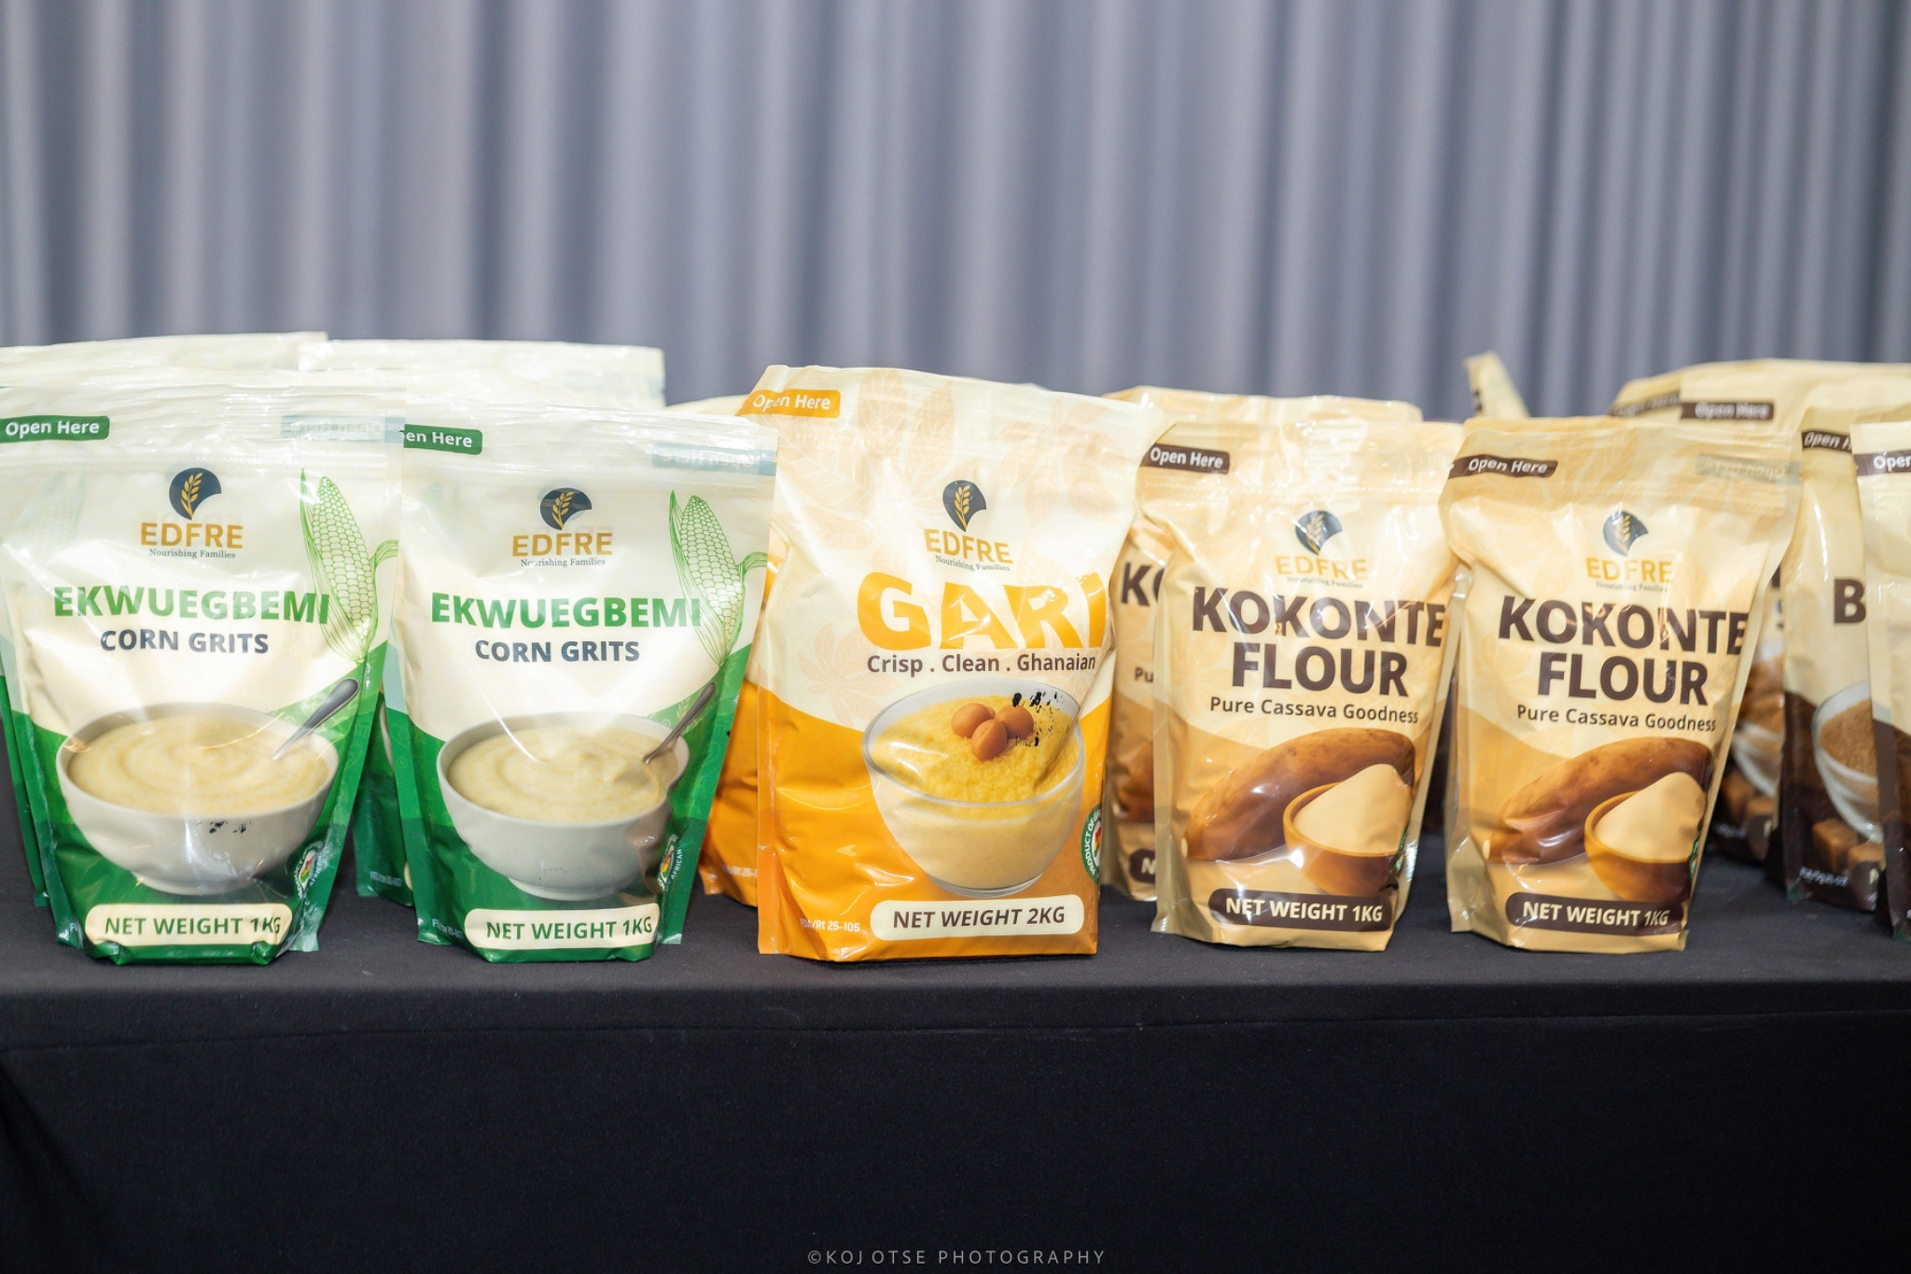
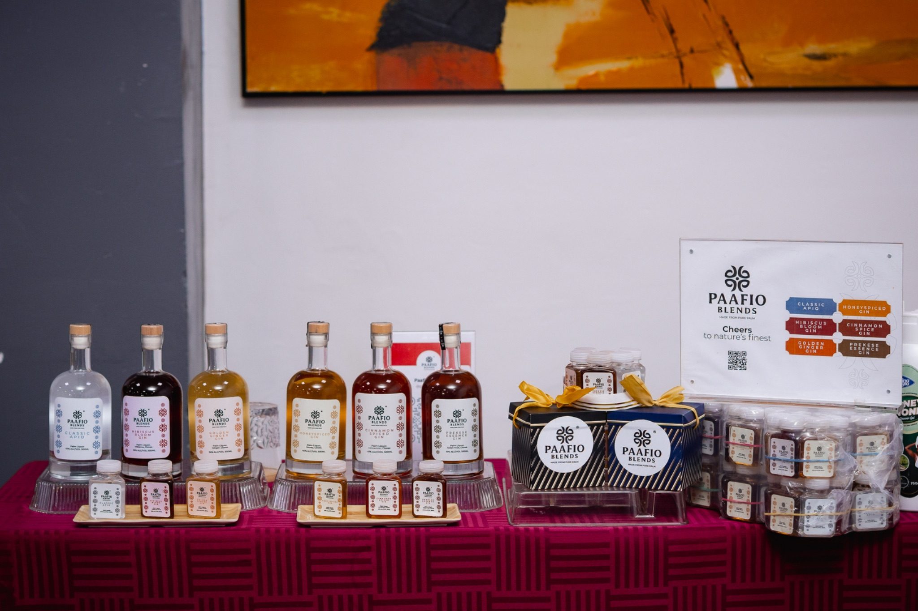
These bi-monthly sessions addressed real-world bottlenecks mentees faced during the course of these businesses running their operations. For example, participants like Grocery Deluxe successfully navigated product focus (their activities were scattered, and their mentor assisted them in prioritizing the most essential products). This resulted in a rebranding, name change, clear distinction of product offerings, a complete overhaul of their packaging which resulted in more consumer interest, and support in navigating the rigorous FDA certification process. Others, such as Koco D’Luv, transitioned to more advanced financial tracking, developing professional pitch decks for investor engagement, and identifying new niches for their products. Edfre Enterprises also conducted a complete packaging overhaul, which directly resulted in their securing shelf space in stores that had previously declined to carry their products.
- Technical Proficiency and Field Exposure: In addition to the mentorship, the final quarter of 2025 saw an intensification of training. Key workshops included:
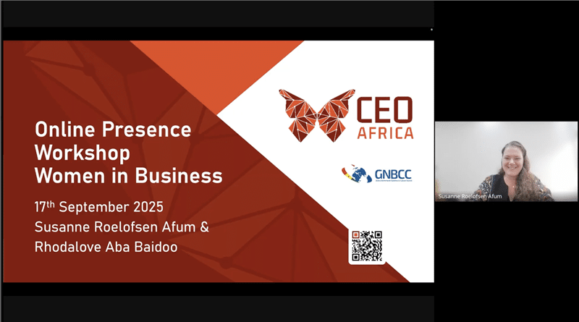
- Strategic Leadership & Management by Dania Williams
- Compliance and Regulatory Adherence by Dania Williams
- Online Presence by CEO Africa
- Financial Literacy and Personal Security by Citadel Accounting and GNBCC member People’s Pension Trust
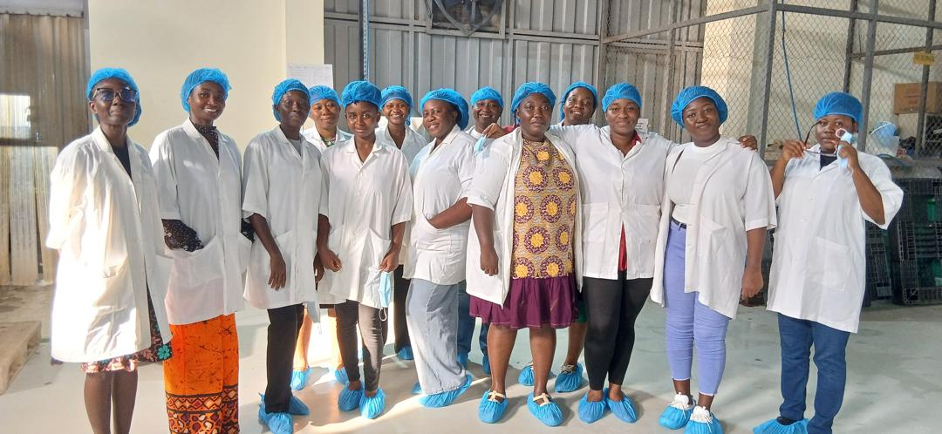
A tour was also organized to Eden Tree, which inspired mentees, allowing them to witness firsthand the standards required to scale an SME into a leading commercial entity and learn from a successful Woman in Business. Eden Tree also engaged their experts to address quality assurance, safety standards, costing, marketing, and production.
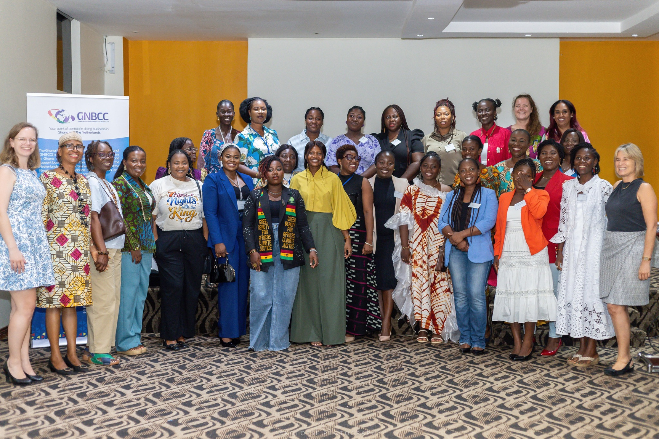
- Closing the 2025 Chapter: The program officially concluded with a Closing Ceremony on Friday, 13th February 2026. During this event, a pre-ceremony evaluation session was organized with the participants to allow the project team to gather data on how mentorship sessions have translated into tangible business outcomes. The latter part of the program was dedicated to celebrating the participants' progress, facilitating networking, and featuring an exhibition for external guests.
- The WIB 2026 (Re)Design
The WIB 2026 program structure has evolved due to ‘recurring needs’ observed during the 2025 edition. Observations of the 2025 cohort revealed that while many entrepreneurs have excellent products, they consistently struggle with three core areas: brand consistency, digital presence, and rigorous financial record-keeping.
A Results-Oriented Three-Pillar Approach:
In 2026, there will be a shift to a model of Measurable Improvements. In addition to receiving mentorship, every participant will be tracked against three specific pillars (which will be implemented with the GNBCC SME desk, GNBCC members, and other mentors/experts).
- Branding & Marketing: It has been observed that product presentation often lags behind product quality. In 2026, "Before and After" assessments of product packaging and brand messaging will be implemented. Success will be measured by the visible enhancement of the product’s appeal and labelling.
- Digital Presence & Visibility: In a digital-first economy, a lack of online visibility is a barrier to growth. The 2026 program mandates the establishment or professionalization of social media and web platforms, with specific training to ensure this is realized.
- Financial Management & Bookkeeping: This remains a significant hurdle for investment readiness. The 2026 program will move beyond one-off workshops to integrated accounting orientations, requiring participants to implement functional tracking systems.
The WIB 2026 edition will be organized from April to June with a kick-off/opening ceremony planned for the 8th of April, 2026.

