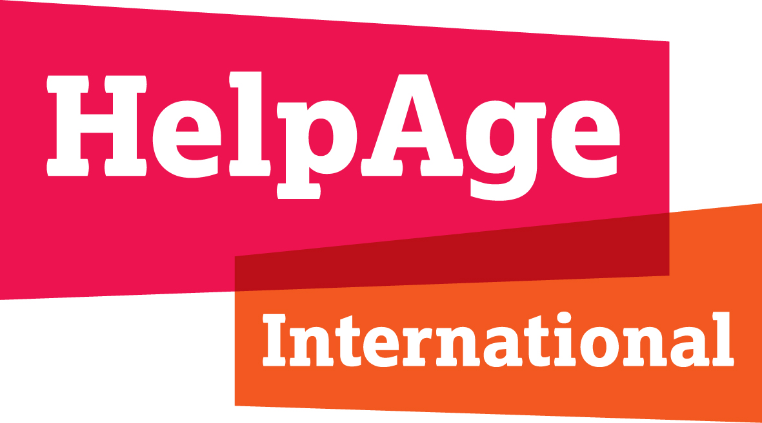
SCORE PROGRAMME
Final Annual Report – Y1

Project Title | SCORE: Strengthening Civil society for Older people’s Rights and Engagement
Reporting Organisation | Amel Association International
Reporting Period | 1 August 2025- 31 March 2026
Report completed by | Mariam Hijazi, Older people program coordinator

Context
During the reporting period, Amel Association International, through its Ageing Unit, focused on establishing the foundations required to operationalize its role as an anchor organisation under the SCORE Programme in Lebanon. The first year was largely dedicated to programme onboarding, internal coordination, capacity assessment, evidence generation, advocacy planning, and the preparation of systems and partnerships necessary to support more structured action on older people’s rights in subsequent phases.
The operating context in Lebanon remained extremely fragile throughout the reporting period. The country continues to face the combined effects of war, prolonged economic collapse, institutional paralysis, currency instability, weakened public services, and deepening multidimensional poverty. These conditions have had a disproportionate impact on older people, particularly older women, older people with disabilities, displaced older people, refugees, and those living alone or dependent on family and caregiver support. The erosion of purchasing power has made basic needs such as medicines, transport, food, heating, assistive devices, and health consultations increasingly unaffordable. At the same time, older people remain largely invisible in social protection, humanitarian targeting, health planning, protection systems, and national decision-making.
Lebanon is undergoing a rapid demographic shift. Older persons aged 60+ represented approximately 11.2% of the population in 2020 and are projected to reach 27.1% by 2050. Yet the systems designed to protect dignity in later life remain fragmented, underfunded, weakly enforced, and largely dependent on family-based coping mechanisms and short-term humanitarian assistance. The absence of comprehensive and enforceable social protection for older people, limited access to affordable medication and geriatric primary healthcare pathways, weak long-term care options, and insufficient participation of older people in public decision-making all reinforce ageism and exclusion.
The context became more challenging following the escalation in Lebanon from March 2026. This escalation affected programme implementation, particularly activities requiring safe travel, in-person participation of older people, stakeholder convening, and coordination with public authorities. In response, Amel applied an adaptive management approach. Several activities were moved to Year 2, following HelpAge International and Sida approval. This approach reflects both accountability for Year 1 commitments and the reality of operating in a volatile and rapidly changing humanitarian and political environment.
Within this context, Amel’s Ageing Unit builds on Amel Association International’s longstanding national presence, multisectoral operational model, community trust, and direct service delivery experience. The Ageing Unit serves as a specialized hub dedicated to advancing the ageing agenda in Lebanon through advocacy, research, capacity building, technical guidance, coordination, and collaboration with national and international stakeholders. It supports Older People Programmes by linking field evidence, community-level needs, older people’s lived experiences, and policy dialogue.
Through SCORE, Amel has worked to strengthen its institutional foundations as an ageing actor, generate evidence on the rights and needs of older people, and prepare the ground for structured engagement with civil society, public institutions, humanitarian actors, academia, and older people themselves. The programme has also supported Amel’s efforts to position ageing not only as a humanitarian concern, but as a development, rights, social protection, health, inclusion, and accountability priority in Lebanon

Overview
During Year 1, the SCORE Programme in Lebanon focused on establishing the foundations for long-term change by strengthening Amel’s institutional readiness, advancing the role of the Ageing Unit, generating evidence on older people’s rights and vulnerabilities, and preparing advocacy and coordination mechanisms to support future policy engagement. While some activities remained preparatory or were delayed due to the security escalation and operational constraints starting from March 2026, meaningful progress was achieved across the three SCORE outcomes.
Outcome 1: Locally anchored national civil society organisations have strengthened capacity to act strategically with and on behalf of older people
Substantial progress was made toward Outcome 1 during the reporting period, particularly in relation to institutional readiness, strategic clarity, and capacity assessment, Amel Association International, through the Ageing Unit, participated in SCORE programme on boarding and HelpAge-led orientation processes, which clarified programme objectives, financial and safeguarding compliance requirements, MEAL expectations, and the role of anchor civil society organisations within the broader SCORE framework.
A key milestone was the completion of Amel’s Organizational Capacity Assessment (OCA), conducted over three days from 15–17 December 2025 using the SHAPE / SCORE framework. The OCA brought together staff and Board representation from across Amel’s organizational structure and provided a structured space for participatory reflection on governance, leadership, influence, external engagement, emergency preparedness, response quality, safeguarding, inclusion, and cross-cutting priorities. The process was not designed as a compliance exercise, but as a learning and action-planning process to identify priorities for capacity strengthening.
The OCA confirmed several important organizational strengths, including Amel’s strong operational experience in emergency response, high community trust, relevance of its interventions, and established expertise in older people programming through the Ageing Unit. At the same time, it identified priority gaps related to strategic dissemination, internal communication, security management, emergency preparedness SOPs, safeguarding dissemination and reporting pathways, institutional MEAL systems, SADDD mainstreaming, inclusion across all sectors, fundraising and advocacy strategies, updated organograms, and organizational visibility.
In parallel, Amel advanced the strategic development of the Ageing Unit. The Unit’s role was further clarified as a national hub for coordination, technical support, evidence generation, training, capacity strengthening, and policy dialogue on ageing. The strategic planning process identified practical priorities such as mapping actors working on ageing in Lebanon, convening civil society and technical stakeholders, creating a knowledge and resource hub, producing evidence and policy recommendations, facilitating peer learning and communities of practice, and promoting older people’s participation in national discussions and decision-making.
The development of the Ageing Unit Advisory Group Terms of Reference represented another important institutional milestone. The Advisory Group is designed to provide strategic, technical, and operational guidance to the Ageing Unit, ensuring that its work is evidence-based, inclusive, participatory, aligned with national priorities, and consistent with international standards such as the Core Humanitarian Standard.
Amel also produced the AGDI National Baseline Assessment and Policy Brief. The assessment examined age, gender, disability, displacement, nationality, poverty, and other dimensions of inequality affecting older people in Lebanon. It drew on 26 secondary sources, 9 focus group discussions with 102 older persons, and 4 key informant interviews with strategic actors. The evidence highlighted that older people in Lebanon face structural exclusion from enforceable social protection, affordable healthcare, age-sensitive humanitarian targeting, protection systems, and decision-making.
Furthermore, three Amel staff participated in the SCORE regional workshop in Ethiopia, strengthening their capacity in programme implementation, safeguarding, and ageing-focused programming. The learning gained informed subsequent SCORE activities, including AGDI analysis, UHC advocacy, organisational strengthening, and more inclusive engagement with older people.
Although the full implementation of capacity-strengthening activities was moved to Year 2 due to the escalation in Lebanon, Year 1 achieved the core foundational objective of clarifying institutional priorities, strengthening coordination structures, and establishing the basis for more systematic capacity development.
Outcome 2: Civil society have a stronger voice and opportunities for dialogue and collaboration with diverse stakeholders that are more engaged in ageing issues
Progress toward Outcome 2 was positive, particularly in relation to evidence generation, advocacy preparedness, and the development of tools and campaign foundations to support structured dialogue on ageing. During the reporting period, Amel participated in orientations and activities linked to the Universal Health Coverage advocacy guide, rights-based approaches to ageing, and climate national analysis work under SCORE. These activities strengthened Amel’s readiness to engage in policy dialogue and provided practical entry points for mobilizing older people, service providers, municipalities, and relevant national stakeholders around ageing-related priorities.
One of the most significant achievements under this outcome was the testing of the UHC advocacy guide for older people. Amel delivered two full training packages in parallel between 9–12 December 2025 in Saida and Mashghara. Across both locations, 32 older people participated, including 29 women and 3 men. Participants included 24 Lebanese and 8 Syrian older people. Accessibility measures such as transport support, appropriate pacing, seating arrangements, and breaks were used to support participation by older people with mobility limitations and chronic conditions.
Another major evidence product was the Climate Resilience National Analysis in Lebanon, developed under SCORE. The analysis reviewed five national climate strategies and 71 climate projects to assess where ageing-related vulnerability is recognized, where it is overlooked, and how policymakers, donors, and civil society can better integrate older people into climate resilience planning and financing. Together, the UHC work and climate analysis significantly strengthened Amel’s evidence base and advocacy readiness.
Furthermore, Amel successfully secured through the Participatory Granting Mechanism a SCORE large grant to strengthen age-sensitive primary healthcare and advocate for improved access to health and care services for older people. Due to the escalation in Lebanon, implementation was postponed to Year 2, with activities to be adapted to the evolving context and operational conditions.

Outcome 3: Older people and organisations representing them are coordinated and active agents of change on holding duty bearers accountable on key priorities
Although formal accountability outcomes, such as policy change or institutional commitments from duty bearers, are expected in later stages of the programme, Year 1 demonstrated increased readiness to support older people’s agency and participation. Amel’s approach under SCORE has begun to create stronger foundations for older people to articulate their rights, shape advocacy priorities, and engage in dialogue with relevant stakeholders. During Year 1, Amel created multiple entry points for older people to engage not only as beneficiaries, but as rights-holders, advocates, and contributors to evidence and policy dialogue under the various activities conducted within Outcome 2 and 1 such as UHC advocacy, AGDI focus group discussions and the creation of the Participatory Granting Mechanism.
Activity Report
Outcome 1: Locally anchored national civil society organisations have strengthened capacity to act strategically with and on behalf of older people
Activity 1.1 Capacity strengthening initiative
During the reporting period, Amel Association International established the initial coordination and implementation arrangements required for its role as a SCORE anchor organisation in Lebanon. The Ageing Unit acted as the main programme lead, with coordination between programme, finance, compliance, and MEAL functions to ensure operational readiness, donor compliance, and alignment with SCORE expectations.
At the beginning of the programme, Amel participated in HelpAge-led inception and compliance meetings conducted between 15 and 16 October 2025, which provided clarity on SCORE objectives, outcomes, implementation strategy, reporting requirements, MEAL expectations, safeguarding standards, financial compliance, and donor requirements. These meetings supported internal alignment and helped define Amel’s responsibilities as an anchor organisation under the programme.
Several preparatory capacity-strengthening activities were undertaken during the first quarter to support institutional readiness for effective programme implementation. Amel participated in programme preparatory meetings between September and October 2025, including sessions focused on programme objectives, the results framework, MEAL requirements, compliance expectations, financial readiness, banking arrangements, signatory rules, and record keeping. The SCORE programme focal point, finance officer, and MEAL focal point were involved in these discussions. Amel also participated in the capacity strengthening focal point induction session on 21 October 2025, IATI training on 20 October 2025, environmental assessment training on 23 October 2025, Anti-Bribery, Fraud and Corruption training on 11 November 2025, Safeguarding training on 13 November 2025, Data Protection training on 26 November 2025, and Security training sessions on 14 January and 2 February 2026. These activities contributed to strengthening Amel’s institutional readiness in relation to reporting, compliance, safeguarding, data protection, financial accountability, environmental risk screening, and staff security.
The capacity strengthening focal point for the reporting period was the Older People Programme Coordinator, covered at 100% from October 2025 onwards under the programme during this phase. This role supported coordination with HelpAge, internal follow-up, preparation for the OCA, planning of subsequent capacity strengthening activities, and alignment between the SCORE programme and Amel’s broader Ageing Unit priorities. Further to the main CS focal point other supporting role were covered by SCORE from December 2025 onwards such as the Ageing Officer (55%), the Bookkeeper (35%) and Finance Coordinator (15%).
Activity 1.1.1 Capacity assessment workshops for each partner
A major achievement under Activity 1.1.1 was the successful completion of Amel’s Organizational Capacity Assessment (OCA). Prior to the workshop, Amel participated in several preparatory activities that helped ensure a clear and structured process. These included the orientation on the OCA Guidelines facilitated by HelpAge International on 3 November 2025, a one-to-one consultation with the Capacity Strengthening Manager and/or consultant in December 2025, and the Capacity Strengthening Methods Orientation on 9 December 2025. These preparatory sessions supported Amel’s understanding of the OCA methodology, the SHAPE / SCORE framework, and the overall approach to identifying organizational strengths, gaps, and capacity-strengthening priorities.
The OCA workshop was then conducted from 15–17 December 2025 using the SHAPE / SCORE framework. It brought together Amel staff from different departments and geographic areas, including programme, operations, human resources, coordination, and support functions, as well as a member of Amel’s Board. The participation of both staff and Board representation enabled a more holistic reflection on organizational capacity, including governance, leadership, accountability, strategic direction, internal communication, safeguarding, discrimination, preparedness, and inclusion. In total, 38 participants attended the workshop, of whom 55% were female. All participants were below the age of 60, and 7% were persons with disabilities..
The OCA was structured over three days around the SHAPE / SCORE domains and was led internally by Older People Program Coordinator and SCORE Programme focal point at Amel. HelpAge International was represented by HelpAge International Response Manager for Lebanon and Syria, who attended the workshop as a SCORE representative due to international travel limitations and security reasons a she was already present in Lebanon and documented the process and key findings for reporting purposes. She did not interfere in the facilitation, group discussions, scoring, or consensus-building process, ensuring that the assessment remained internally owned and reflective of Amel’s own analysis. Day 1 focused on Governance and Leadership. Day 2 focused on Influence and Cross-Cutting Issues. Day 3 focused on Preparedness, Response Quality, and Inclusion. Each domain was explored through facilitated group discussions, evidence-based reflection, plenary validation, consensus building, scoring at organizational, human, and programme levels, and identification of priority organizational gaps. The workshop emphasized learning, reflection, and action planning rather than compliance or performance assessment.
The OCA identified several key strengths. These included Amel’s strong operational experience in emergency response, high relevance of interventions, strong community trust, and established expertise in older people programming through the Ageing Unit. Participants demonstrated strong ownership and openness, including willingness to reflect critically on sensitive organizational issues such as safeguarding, discrimination, internal communication, and emergency preparedness.
At the same time, the assessment identified several priority gaps. These included limited dissemination and operationalization of strategic documents, weak internal communication and fragmented decision-making, unclear reporting lines and accountability structures, gaps in standardized HR systems and staff development planning, limited institutionalization of safeguarding practices, lack of consolidated emergency SOPs, limited staff awareness of security policies, project-based MEAL systems, inconsistent mainstreaming of SADDD, and insufficient integration of older people’s inclusion across all sectors.
The workshop generated a consolidated list of organizational priorities, including:
- strategic planning and internal alignment;
- security management and emergency preparedness SOPs;
- strengthening internal communication channels;
- mainstreaming inclusion of older people across all programmes;
- safeguarding policy dissemination, training, and enforcement;
- updated organogram and accountability structures;
- staff capacity development plans linked to performance appraisals;
- development of fundraising and advocacy strategies;
- institutionalization of MEAL systems and SADDD;
- development and adoption of anti-discrimination, equal opportunity, anti-bullying, harassment, anti-fraud, and whistleblowing policies;
- and strengthening organizational visibility and external communication.

The OCA therefore provided a clear roadmap for future capacity strengthening under SCORE and beyond. It also highlighted an important institutional lesson: while Amel has strong programmatic experience and field-level expertise, some capacities need to be further institutionalized at organizational and systems level to ensure sustainability, consistency, accountability, and quality across departments and programmes.
Activity 1.1.2 Grant to 9 partners for capacity building initiatives
During the reporting period, Amel started drafting the organizational improvement plan (OIP) based on the findings of the OCA. However, implementation did not take place within Year 1. The activity was delayed and moved to Year 2, with the relevant allocation reprogrammed for implementation after March 2026. This shift was necessary due to the escalation in Lebanon, which affected the feasibility of moving forward with planned capacity-building activities within the original timeframe.
The delayed implementation should therefore be understood as a timing-related adjustment rather than cancellation of the activity. The remaining funds will be used in Year 2 to complete the planned capacity-building actions in line with updated operational realities and programme priorities.
Activity 1.1.4 In-person capacity building workshop
Between 19–24 January 2026, three Amel staff participated in the regional capacity-building workshop organized by HelpAge International in Ethiopia. The participants were the Older People Programme Coordinator; the Health Coordinator; and the Ageing Officer (2 female and 1 male).
Through this workshop, Amel strengthened its engagement with SCORE partners and the wider HelpAge Global Network. The workshop enhanced Amel’s understanding of locally led development approaches, partnership principles, programme compliance, gender and ageing analysis, results-based implementation, safeguarding, accountability, and the strategic direction of SCORE. It also created space for peer learning among anchor civil society organisations, enabling partners to exchange experiences, reflect on shared challenges, and identify opportunities for collaboration.
The workshop was particularly important for Amel because it clarified the programme’s objectives, scope, expected deliverables, and implementation modalities. It also reinforced the role of anchor civil society organisations in shaping national ageing agendas, strengthening locally led action, and connecting community-level evidence with policy dialogue and advocacy.
Learning from the Ethiopia workshop was applied in several ways. It informed Amel’s preparation for subsequent SCORE activities, including the OIP drafting following the OCA, Ageing Unit strategic planning, UHC advocacy work, AGDI analysis, climate resilience analysis, and engagement with HelpAge technical advisors. The workshop also reinforced the importance of inclusive and participatory approaches, which were later reflected in Amel’s engagement with older people through UHC training, AGDI focus group discussions, and rights consultations.
Activity 1.1.5 Age, gender and inclusion assessment grants
During the reporting period, Amel advanced the AGDI National Baseline Assessment for Lebanon, which focuses on the age and gender dimensions of inequality affecting older persons, with attention to disability, displacement, nationality, poverty, geographic isolation, digital exclusion, health access, social protection, safety, participation, and access to services.
Preparatory work for the assessment began before the formal data collection phase. This included technical discussions and one-to-one follow-up calls with the HelpAge International Age and Gender inclusion Advisor in November 2025 and February 2026 to review Amel’s current approach to age, gender, and disability inclusion mainstreaming and to support the planning and organization of the assessment activity. Amel’s participation in the SCORE training in Ethiopia also contributed to strengthening the team’s understanding of AGDI concepts, inclusive programming, and the use of evidence to inform advocacy and policy engagement.
In March 2026, the AGDI consultant completed the desk review, which included the review of 26 secondary sources, and started the preparatory activities to carry out the primary data collection inclusive of 9 focus group discussions and 4 key informant interviews with strategic actors. Primary data collection will cover 8 locations across 5 governorates and will target older persons aged 60+ in all their diversity, including Lebanese older people, Syrian older refugees, displaced older people, older women, older men, older people with disabilities, and older people facing socioeconomic vulnerability.
The assessment will generate an important evidence base on the inclusion gaps and barriers affecting older persons in Lebanon. The findings will inform an AGDI Policy Brief and will be used in Year 2 to support dissemination, policy engagement, roundtable discussions, and follow-up advocacy activities under SCORE.
Activity 1.2 Core funding for anchor national entities
Core funding under Activity 1.2 supported Amel’s ability to maintain the staffing, coordination, and operational capacity required to act as a national anchor organisation on ageing under SCORE. These resources were essential in a context where Lebanon’s economic crisis, declining donor funding, security risks, and increased humanitarian needs have placed significant pressure on civil society organisations and staff.
The core funding contributed to the Ageing Unit’s operational continuity and enabled Amel to maintain follow-up on SCORE planning, reporting, coordination with HelpAge, evidence generation, and internal alignment. It also supported staff time and institutional functions necessary to deliver activities under the programme, including coordination between programme, finance, compliance, MEAL, and field teams via the Ageing Officer (55% funded through SOS).
The funding also supported capacity building through the Ageing Unit / SOS line, including the two-day training for staff on identifying and responding to abuse and neglect of older people. The training took place on 10–11 February 2026. It focused on defining abuse and neglect of older people, identifying types of abuse, recognizing risk factors and warning signs, applying safe communication approaches, understanding confidentiality and informed consent, documenting concerns appropriately, and following referral pathways. This training was directly relevant to Amel’s safeguarding, protection, and older people programming priorities, strengthening field staff capacity to identify risks, communicate safely with older people, uphold confidentiality and informed consent, and refer cases according to appropriate pathways. In total there were 25 participants, with 20 female and 5 male, all of them were field staff and frontliners, with 2% people with disability.
The remaining balance under the core funding line was moved to Year 2 in line with the approved Year 2 plan and will be used to support continuity of activities and completion of actions that could not be fully implemented during Year 1 due to the escalation in Lebanon and related operational constraints.

Outcome 2: Civil society have a stronger voice and opportunities for dialogue and collaboration with diverse stakeholders that are more engaged in ageing issues
Activity 2.1 Project grants to CSOs for engagement with government and stakeholders to build momentum and broad support for action on ageing issues
Activity 2.1.1 Larger grants to CSOs
Preparatory work for the large grant process started before the formal launch of the call for proposals. In November 2025, Amel participated in two consultation sessions with Anchor CSOs to inform the design of the Participatory Granting Mechanism. Amel also contributed to the survey circulated during the same period, which helped shape the grant guidelines and ensure that the mechanism reflected partners’ perspectives and operational realities.
In December 2025, Amel completed the nomination process for participation in the SCORE governance structures linked to the grant mechanism. Mohammad Zayed, Health Coordinator at Amel, was nominated to the Grants Management Committee, while Daniella Khalil, Protection Programme Coordinator, was nominated to the Steering Committee. Due to the escalation in Lebanon and related operational constraints, the Steering Committee member was not able to actively participate during Year 1, but participation is expected to resume in Year 2.
In addition, in January 2026, the SCORE workshop in Ethiopia included practical sessions that supported Anchor CSOs to better understand the large grant process, reflect on potential areas of intervention, and link proposed activities to SCORE outcomes.
The formal launch of the large grant call for proposals took place in January 2026. Amel also participated in the drop-in session conducted on 4 February 2026, which helped clarify the call requirements, eligibility criteria, and proposal development process. Following review by the Grants Management Committee and validation by the Steering Committee, Amel’s large grant proposal under Outcome 2 was selected. The proposed initiative focused on geriatric and age-sensitive primary healthcare, with the objective of strengthening service responsiveness to older people and advancing advocacy around older people’s access to health and care. The proposal aimed to link capacity strengthening, service-level improvements, and policy dialogue by engaging PHC actors and relevant public stakeholders.
The activity was not implemented during Year 1 because of the escalation in Lebanon and its impact on safe and timely implementation. The activity has therefore been moved to the Year 2 implementation plan, where it will be adapted based on access, security conditions, and the availability of relevant stakeholders.
Activity 2.1.2 Smaller grants to smaller CSOs
Amel did not participate in the small grants process during the reporting period. No small grant outreach, application review, selection, or grant management was undertaken by Amel in Year 1. This activity is therefore not applicable for Amel for the reporting period.
Activity 2.3 Initiatives, tools, and analysis to strengthen CSOs for national and regional advocacy
Activity 2.3.1 Pilot of Universal Health Coverage voice toolkit
The pilot of the Universal Health Coverage voice toolkit made a substantial contribution to strengthening Amel’s advocacy work on older people’s access to health and care services. Initial familiarisation with the UHC Advocacy Guide took place in November 2025 during an orientation organized by HelpAge UHC consultant. Afterwards, Amel delivered two full training packages between 9–12 December 2025 in Saida and Mashghara. The Saida training was conducted at Ahlouna Association, while the Mashghara training was conducted at Al Maram Venue. Each training was delivered over four consecutive days, amounting to eight full training days across the two locations.
A total of 32 older people participated in the training. In Saida, 16 participants attended, all women, including 11 Lebanese and 5 Syrian participants. In Mashghara, 16 participants attended, including 13 women and 3 men, with 13 Lebanese and 3 Syrian participants. Overall, the training reached 29 women and 3 men, including 24 Lebanese and 8 Syrian older people. All 32 participants are counted as older people for the purpose of the outreach table.
The training strengthened participants’ understanding of Universal Health Coverage and its relevance to older people’s rights, access to PHC, chronic disease management, and access to essential medicines. It also created a participatory space for older people to reflect on barriers they face in accessing healthcare, including medication costs, transport, unclear referral pathways, service accessibility, and limited age-sensitive communication.
In addition to older people, Amel engaged community stakeholders to support follow-up advocacy and strengthen linkages. These included municipal representatives, primary healthcare actors, the head of Amel’s Saida PHC, local service providers, CSOs, associations, volunteers, caregivers, and family members. Although these stakeholders were included within the overall training environment, separate disaggregated data for these sub-groups was not systematically recorded.
The testing of the guide generated practical feedback on how the UHC advocacy guide can be made more accessible and relevant in Lebanon. Amel also participated in the feedback review meeting organized on 29 January 2026 and facilitated by UHC consultant and Healthy Ageing Advisor at HelpAge International. This session provided an opportunity to reflect on the testing process, discuss learning from different country contexts, and identify practical adjustments needed to strengthen the guide’s usability with older people.
The training and testing process confirmed the value of simple language, Arabic materials, visual aids, storytelling, role play, and frequent breaks when working with older participants. It also showed that advocacy tools need to be grounded in older people’s daily realities, particularly the affordability of medication, availability of NCD medicines, access to transport, and the need for age-friendly PHC services. The feedback will help ensure that the adapted UHC advocacy materials are more inclusive, accessible, and relevant to older people in Lebanon.
Building on the training, Amel developed a joint campaign action plan to mobilize older advocates in Saida and Mashghara. The campaign aims to support older people to participate in community mini-sessions, collect testimonies, engage with PHC actors and municipalities, and advocate for practical improvements such as priority queues, clearer referral pathways, accessible information, and improved access to essential NCD medicines.
Due to the escalation in Lebanon from March 2026, the UHC campaign activities were moved to Year 2. The remaining funds under Activity 2.3.1 were also moved to Year 2 and will be used to complete the campaign and related advocacy actions. This delay reflects an adaptive management decision to ensure older people’s safety and meaningful participation rather than implementing campaign activities under unsafe or unstable conditions.
Activity 2.3.2 Climate resilience national analysis
Amel developed the Climate Resilience National Analysis in Lebanon under the SCORE Programme to examine how ageing is integrated into national climate policy, climate finance, disaster risk reduction, environmental health, and adaptation planning. As part of the preparatory process, Amel participated in the initial orientation session held on 6 November 2025, which introduced the purpose, scope, and expected approach of the climate resilience analysis. The session helped clarify how the analysis should assess the visibility of older people within climate-related policies, strategies, and programmes, and supported Amel in framing the assessment in line with SCORE’s wider objective of strengthening evidence-based advocacy on older people’s rights and inclusion.
The analysis reviewed five national climate strategies and 71 climate projects to identify where ageing-related vulnerability is recognised, where it is missed, and how donors, policymakers, and civil society can close the gap.
The analysis found that Lebanon’s climate hazards are accelerating, while the policy and finance architecture continues to treat older people as a marginal or generic vulnerable group. Headline indicators from the analysis show that heat-related mortality for people aged 65+ could rise significantly by 2050 under high-emissions scenarios, inland regions such as Bekaa and Hermel could face up to 60 days per year above 35°C by 2050, and only 2 of 71 reviewed climate projects included targeted interventions for older people.
The analysis also reviewed Lebanon’s updated climate policy framework, including the National Adaptation Plan, updated Nationally Determined Contribution 3.0, and Long-Term Low Emission Development Strategy. While these frameworks increasingly reflect gender and youth considerations, ageing is not systematically integrated into planning, consultation, decision-making, monitoring, or financing. Older people are generally mentioned only within broader vulnerable groups, without specific action points, indicators, or budget allocations.
The analysis therefore identified important entry points for advocacy and programming. These include integrating age, gender, disability, and poverty-disaggregated data into climate vulnerability assessments; ensuring older people’s participation in climate governance and local adaptation planning; improving age-responsive climate finance tracking; linking climate resilience to health, social protection, and emergency preparedness; and supporting intergenerational approaches to climate action.
The remaining balance under Activity 2.3.2 was moved to Year 2 and will be used to complete related actions, including dissemination, validation, policy engagement, and integration of findings into Amel’s advocacy and programme design. This timing adjustment was necessary due to the escalation in Lebanon and the reduced feasibility of convening stakeholders safely during the original reporting period.
Activity 2.3.4 Consultations on joint human rights positions
In October 2025, Amel participated in the Rights Orientation session conducted by HAI’s Rights Advisor and consultant, which reinforced knowledge on rights-based approaches to ageing and strengthened alignment with SCORE advocacy principles and frameworks. Further preparatory work was also completed during the reporting period. On 5 February 2026, Amel participated in the orientation session on the consultation process, which provided detailed guidance on the methodologies, materials, and tools to be used during the consultations. On 16 February 2026, Amel also participated in the capacity-strengthening session for consultation facilitators, which supported preparation for the participatory rights dialogues and individual interviews. These preparatory sessions strengthened Amel’s readiness to implement the rights consultations using a structured, participatory, and rights-based approach.
The implementation of the Participatory Rights Dialogue itself did not take place during the reporting period and will be reported under Year 2 due to the escalation of conflict towards the end of the reporting period.
Outcome 3: Older people and organisations representing them are coordinated and active agents of change on holding duty bearers accountable on key priorities
Activity 3.1 Project grants for amplified voice and coordinated action on rights
The preparatory work to set up the participatory granting mechanism is reported under Outcome 2 , no further action has been taken under Outcome 3.
Activity 3.2 Supporting the Global Network movement for change
No standalone activities were implemented during the reporting period. Amel’s contribution to the wider HelpAge Global Network movement during Year 1 was primarily through participation in the Ethiopia regional capacity-building workshop, engagement with SCORE technical processes, and contribution to evidence and learning on ageing, inclusion, UHC, climate resilience, and rights-based approaches in Lebanon.
Activity 3.3 Learning from action and feeding back into the programme
Learning activities under this area remained early during Year 1, as several implementation activities were still in preparatory stages or moved to Year 2. However, learning was generated through the OCA, UHC guide testing, and climate resilience analysis. These activities provided important feedback on how Amel can strengthen older people’s participation, improve age-friendly facilitation, mainstream SADDD, and adapt advocacy approaches to Lebanon’s volatile context.
Challenges and solutions
The most significant challenge was the escalation in Lebanon from March 2026, which affected mobility, safety, field access, and the feasibility of convening older people and stakeholders. Activities requiring in-person participation, such as campaign actions, stakeholder dialogues, dissemination events, and grant implementation, had to be reconsidered and moved to Year 2 to ensure participant safety and implementation quality.
In response, Amel applied an adaptive management approach. Activities were sequenced based on feasibility and risk, with priority given to foundational work that could be completed safely, such as evidence generation, internal planning, tool development, and strategic preparation. Activities requiring broader public engagement were moved to Year 2 and will be adapted based on the security situation and operational access.
Challenge | Effect on implementation | Solution / adaptation
Escalation in Lebanon from March 2026 | Delayed in-person campaign actions, stakeholder engagement, grant implementation, and consultations. | Activities moved to Year 2; subsequent progress included where activities were completed by the time of final reporting.
Economic crisis and high transport | Reduced ability of older people to participate | Transport and accessibility considerations integrated into activities
Weak public systems and fragmented governance | Policy engagement required careful sequencing and realistic stakeholder targeting. | Amel focused on evidence generation and practical entry points with PHC actors, municipalities, MoPH/MoSA stakeholders, CSOs, and humanitarian actors.
Operational and finance compliance | Aligning internal financial management and reporting systems with SCORE requirements (banking arrangements, signatory rules, documentation, and record-keeping) required additional preparation to ensure readiness for core funding and capacity strengthening grants. | Amel has assigned a designated staff focal points responsible for financial management.
Stakeholder engagement and advocacy preparation | Limited formal opportunities for engagement with government and national duty bearers in Lebanon may constrain Outcome 2 advocacy activities during the early phase of the programme | The Ageing Unit has prioritised informal coordination with CSOs, networks, and community actors to map stakeholders, assess advocacy entry points, and plan context-appropriate interventions.

MEAL
During the reporting period, MEAL work focused on establishing the monitoring foundations required for SCORE implementation and ensuring alignment with HelpAge reporting requirements. Amel participated in programme onboarding and MEAL-related orientation processes, including familiarisation with the results framework, reporting requirements, financial and narrative documentation expectations, and the importance of collecting sex, age, and disability disaggregated data.
Amel also contributed to the SCORE baseline study by providing the requested baseline information and organisational inputs. While Amel was not able to fully participate in dedicated baseline-related sessions, the information shared helped inform the baseline process and provided relevant context on Amel’s current systems, programme priorities, and capacity-strengthening needs. This preparatory MEAL work supported a clearer understanding of reporting expectations and helped lay the foundation for monitoring progress under the SCORE Programme..
The OCA process highlighted that while MEAL functions exist within Amel’s project structures, further institutionalization is required to ensure consistent organization-wide use of indicators, SADDD, impact measurement, learning, and evidence-based decision-making. Institutional MEAL strengthening was therefore identified as a core organizational priority under the OIP.
Data collection under SCORE contributed to a stronger evidence base on older people. The UHC training generated participant data and qualitative feedback on the accessibility and relevance of the advocacy guide and the climate resilience analysis added policy and financing evidence by reviewing national strategies and climate projects.
Activity | Total | Female | Male | Older People 60+ | Adults <60 | PWDs / functional limitations | Notes
OCA Workshop | 38 | 21 | 17 | 0 | 38 | 4 | 15–17 Dec 2025; staff and Board members; SHAPE/SCORE framework.
Ethiopia Capacity-Building Workshop | 3 | 2 | 1 | 0 | 3 | 0 | Mariam Hijazi, Mohamad Zayed, Yara Wehbe; 19–24 Jan 2026.
UHC Advocacy Guide Training - Saida | 16 | 16 | 0 | 16 | 0 | 16 | All participants counted as older people; 11 Lebanese, 5 Syrian.
UHC Advocacy Guide Training - Mashghara | 16 | 13 | 3 | 16 | 0 | 16 | All participants counted as older people; 13 Lebanese, 3 Syrian.
UHC Training Total | 32 | 29 | 3 | 32 | 0 | 32 | Two full deliveries, 9–12 Dec 2025.
Climate Resilience Analysis | 5 | 4 | 1 | 1 | 4 | 0 | Reviewed 5 national strategies and 71 climate projects.
Abuse and Neglect Training for Staff | 25 | 20 | 5 | 0 | 25 | 2 | 10–11 Feb 2026; trainer Reem Ibrahim; under SOS/Ageing Unit capacity building.

Cross cutting issues:
Gender
Gender was a central consideration across Amel’s SCORE activities. The UHC training reached 29 women and 3 men, reflecting strong participation of older women in health advocacy discussions. The AGDI assessment also provided an important opportunity to further investigate how gender inequality compounds over the life course, particularly for older women who may have limited access to formal work, social insurance, pensions, property, independent income, mobility, and GBV response. Older women’s unpaid care responsibilities also continue into later life, often while they themselves face chronic illness, poverty, displacement, or disability. Concrete findings will be shared in the next reporting period.
The OCA process also highlighted the need to further strengthen and systematize gender mainstreaming across Amel’s programmes and internal systems. While Amel’s work is guided by principles of inclusion, non-discrimination, safeguarding, and equitable access to services, the assessment showed that more consistent institutional guidance is needed to ensure that gender is systematically reflected in programme design, implementation, monitoring, and reporting. A key area for strengthening is the consistent collection and use of sex, age, and disability disaggregated data across MEAL systems and all programmes, so that inequalities affecting older women, older men, and older people with disabilities are more clearly identified and addressed. Amel will therefore work to further mainstream SADD across its MEAL and programme processes and to clarify related internal policy and guidance on gender and inclusion.

Disability
Accessibility considerations were applied in a practical way across SCORE-related activities, particularly through the selection of accessible venues, adaptation of materials where needed, and the use of flexible facilitation approaches to support the participation of older people, including older people with disabilities.
The OCA process also created space for Amel to reflect more critically on how disability inclusion is currently addressed across organisational and programme systems. While inclusion and non-discrimination are already part of Amel’s working approach, the discussion showed that these practices need to be more consistently documented, guided, and monitored across programmes. One area identified for further strengthening is the systematic use of sex, age, and disability disaggregated data, not only for reporting purposes but also to better understand barriers faced by older people with disabilities and to inform programme adaptations, referrals, and advocacy priorities.

Climate change
Climate change was addressed through the national climate resilience analysis, which examined the inclusion of older people in Lebanon’s climate policy and finance architecture. The analysis found that older people are insufficiently integrated into national climate strategies, despite their heightened exposure to heat, health risks, displacement, poverty, limited mobility, and service disruption. The analysis also showed that climate policy frameworks tend to refer to older people only as part of broad vulnerable groups, without specific action points, indicators, financing mechanisms, or participation pathways.
Amel will use the climate analysis to advocate for age, gender, disability, and poverty-disaggregated data in climate vulnerability assessments; the inclusion of older people in climate governance; age-responsive climate finance tracking; and stronger links between climate resilience, health, social protection, and disaster risk reduction. This will also support Amel’s broader objective of positioning ageing as a cross-sectoral priority in Lebanon.

Accountability and participation
Participation and accountability were promoted through the UHC training. This activity created spaces for older people to identify their own priorities and shape advocacy messages. The Ageing Unit Advisory Group is also expected to strengthen accountability by ensuring that Amel’s work is evidence-based, inclusive, participatory, and aligned with CHS principles. In Year 2, Amel will work to further strengthen feedback and accountability mechanisms for older people, including more consistent documentation of how older people’s input informs programme and advocacy decisions.
SEAH and Corruption
During the reporting period, Amel maintained its commitment to preventing safeguarding violations, sexual exploitation, abuse and harassment (SEAH), fraud, bribery, and corruption. SCORE onboarding and compliance processes reinforced the importance of safeguarding, accountability, donor compliance, and reporting responsibilities.
The OCA identified safeguarding dissemination, training, and enforcement as an organizational priority. It also highlighted the need to further strengthen reporting pathways, policy dissemination, and the practical implementation of existing protection and accountability mechanisms. In response, safeguarding and protection-related capacity strengthening were included in Amel’s organizational priorities and Year 2 planning.
Amel also implemented a two-day staff training under the SOS fund / Ageing Unit capacity building line on identifying and responding to abuse and neglect of older people. The training strengthened field staff understanding of abuse and neglect, safe disclosure, confidentiality, informed consent, documentation standards, and referral pathways. While this training focused specifically on older people’s protection risks, it also contributed to the broader safeguarding culture and capacity of the organization.
During the reporting period, no allegations or cases related to safeguarding, SEAH, fraud, bribery, or corruption were reported. Reporting and complaint mechanisms remain in place, and Amel will continue strengthening internal awareness, reporting pathways, and accountability mechanisms as part of its ongoing organizational capacity strengthening.
Finance
The project demonstrated controlled financial performance during the reporting period, with several activity balances intentionally moved to Year 2 because of implementation delays linked to the escalation in Lebanon and the need to complete activities safely and meaningfully. The total amount provided to Amel was GBP 61,312.33 including 6,300 GBP of SOS. Following a re-allocation of the SOS funds, the total budgeted was GBP 59,970.61. Total expenditure for the reporting period was GBP 44,813.82, leaving a budget balance of GBP 15,156.79 and an overall utilization rate of approximately 74.73%.
The underspend should be understood primarily as a timing-related variance rather than cancelled implementation. The remaining balances will support completion of activities, campaign actions, dissemination, and follow-up work in Year 2.
Budget line | Approved Budget GBP | Expenses GBP | Balance GBP | % Spent | Explanation
1.1.1 Capacity assessment workshops | 5,000.00 | 4,508.91 | 491.09 | 90.18% | Positive exchange rate difference / cost efficiency.
1.1.2 Grant to 9 partners for capacity building initiatives | 10,000.00 | 0.00 | 10,000.00 | 0.0% | Implementation moved/reallocated to Year 2 as explained in the Activity section above.
1.1.4 In-person capacity building workshops - travel | 4,600.00 | 3,864.40 | 735.60 | 84.01% | Remaining amount moved to Year 2 as explained in the Activity section above.
1.1.5 Age, gender and inclusion assessment grants | 1,200.00 | 996.16 | 203.84 | 83.01% | Remaining amount moved to Year 2 and will be used to complete related actions as explained in the Activity section above,
1.2 Core funds for anchor national entities | 4,958,61.00 | 4,958.61 | 0 | 100% | The original budget was 6,300 , but it was adjusted to the actual expenditure with remaining balance moved to Y2.
2.3.1 Pilot of UHC voice toolkit | 6,000.00 | 3,863.48 | 2,136.52 | 64.39% | Remaining amount moved to Year 2 to complete campaign actions as explained in the Activity section above.
2.3.2 Climate resilience national analysis | 6,000.00 | 4,597.70 | 1,402.30 | 76.63% | Remaining amount moved to Year 2 to complete dissemination, validation, and follow-up actions as explained in the Activity section above.
4.2.1 Capacity Strengthening Focal Point | 21,533.33 | 21,532.52 | 0.48 | 100.0% | Fully used.
Overhead cost | 679.00 | 492.04 | 186.96 | 72.47%
TOTAL | 59,970.61 | 44,813.82 | 15,159.79 | 74.73% | Overall balance moved to Year 2 where relevant.

Case Studies:
One of the most important changes generated through the SCORE Programme was not only the delivery of activities with older people, but the shift in how Amel engaged older people within advocacy and programme design processes. Through the testing of the Universal Health Coverage (UHC) advocacy guide in Saida and Mashghara, Amel moved beyond consulting older people as beneficiaries and created a space where they could actively analyse barriers, identify advocacy priorities, develop messages, and reflect on how to engage local decision-makers around issues affecting their right to health.
The training reached older women and men directly affected by Lebanon’s economic crisis, health system pressures, and increasing costs of medication and care. Many participants spoke about the daily struggle to access chronic disease medication, transportation to health services, and clear information on available support. What made the activity particularly meaningful was that older people were not asked only to describe their needs; they were supported to understand these needs as rights-based issues and to translate them into practical advocacy messages.
The training also demonstrated that older people should be included in all advocacy actions from the beginning, not only as community members consulted after decisions are made, and not only alongside technical stakeholders. Older participants showed that they are able to identify real barriers, propose feasible solutions, and guide advocacy priorities based on lived experience. This changed the way Amel viewed follow-up advocacy work. It reinforced the need to place older people at the centre of advocacy planning, stakeholder engagement, campaign design, and accountability processes.
The experience opened an important door for Amel’s broader programming. It showed that older people can and should be engaged as decision-makers in other projects, not only in ageing-specific advocacy activities. This learning has already influenced Amel’s thinking in other ongoing initiatives, including anticipatory action work with HelpAge. In that project, Amel conducted focus group discussions with older people not only to inform project design, but also to understand whether planned actions are meaningful, relevant, and likely to create impact from older people’s own perspective.
This represents a small but significant institutional change. SCORE helped Amel strengthen its practice of meaningful participation by moving from “asking older people about their needs” toward “involving older people in shaping decisions.” The UHC training confirmed that older people’s lived experience is not only evidence for reports; it is a source of analysis, leadership, accountability, and advocacy direction.
The process also strengthened local-level engagement. In Mashghara, the participation of local stakeholders, including municipal actors, helped create momentum for continued dialogue on older people’s access to health services. This demonstrated the value of bringing older people and relevant decision-makers into the same advocacy process, while ensuring that older people’s voices remain central.
Going forward, Amel will build on this learning by systematically promoting older people’s participation in advocacy, programme design, monitoring, and learning processes. This includes creating more opportunities for older people to contribute to community consultations, policy discussions, campaign actions, and project design processes across different thematic areas. Through this approach, SCORE has contributed to a broader shift in Amel’s work: older people are increasingly recognized not only as service users, but as rights-holders, advocates, and decision-makers.
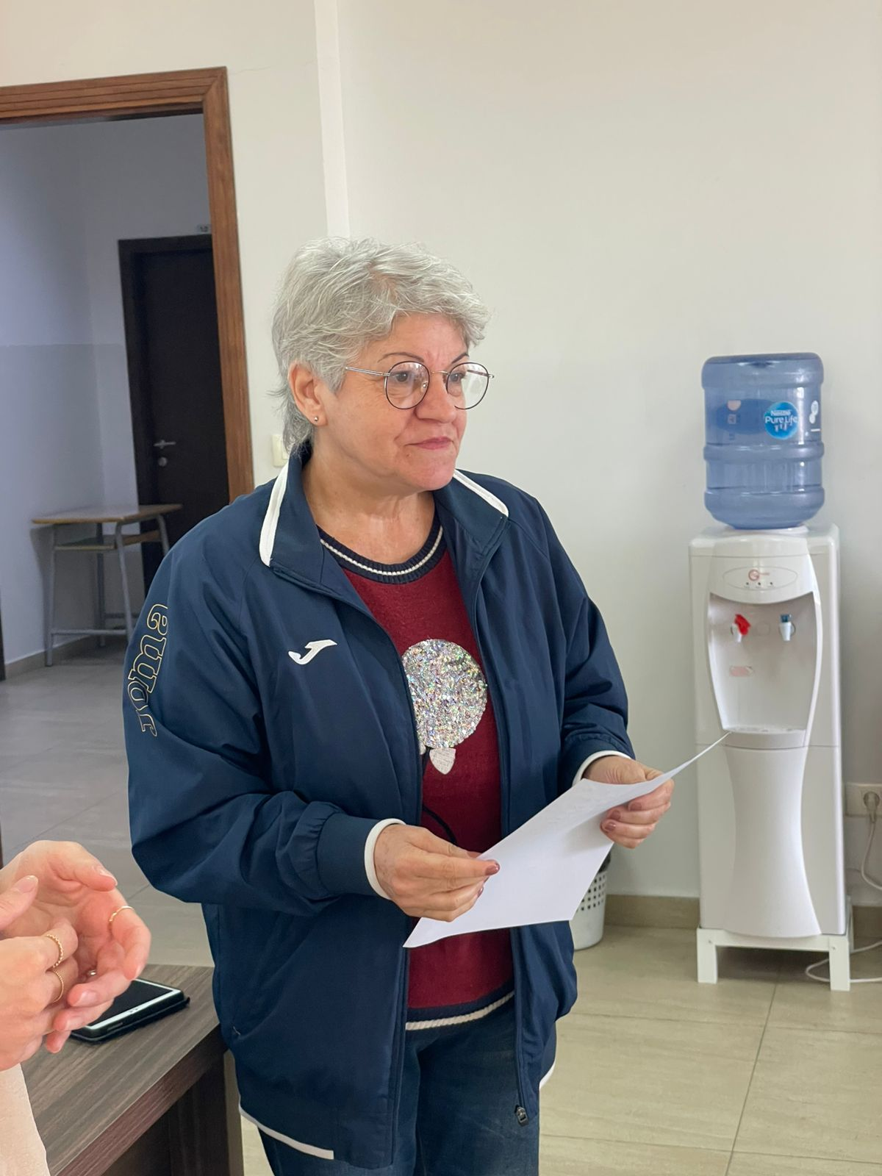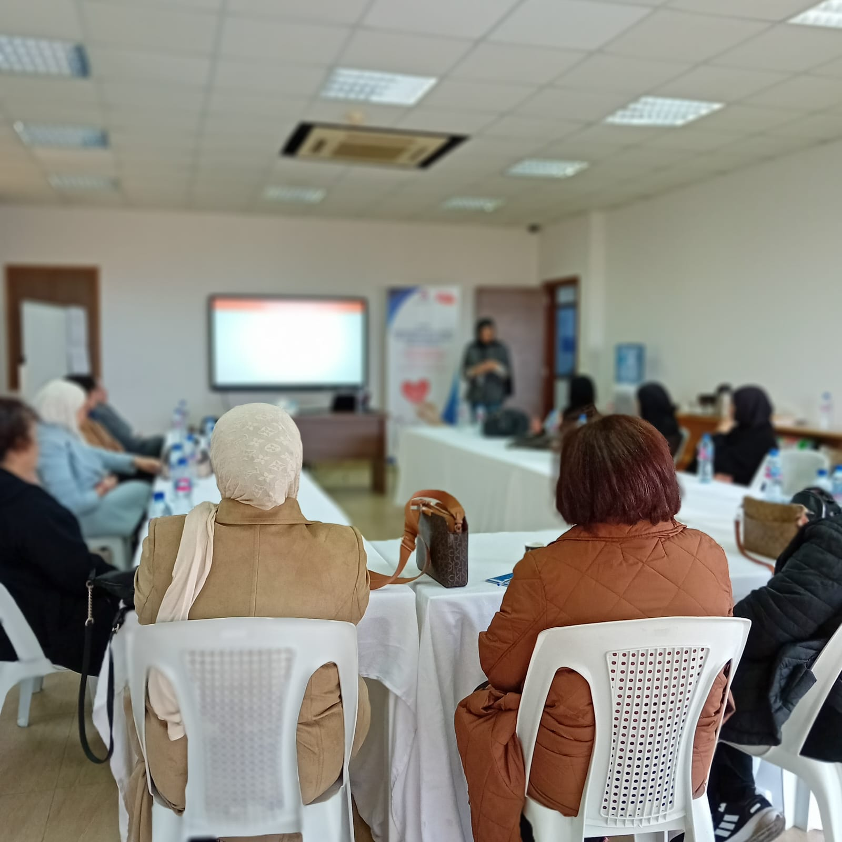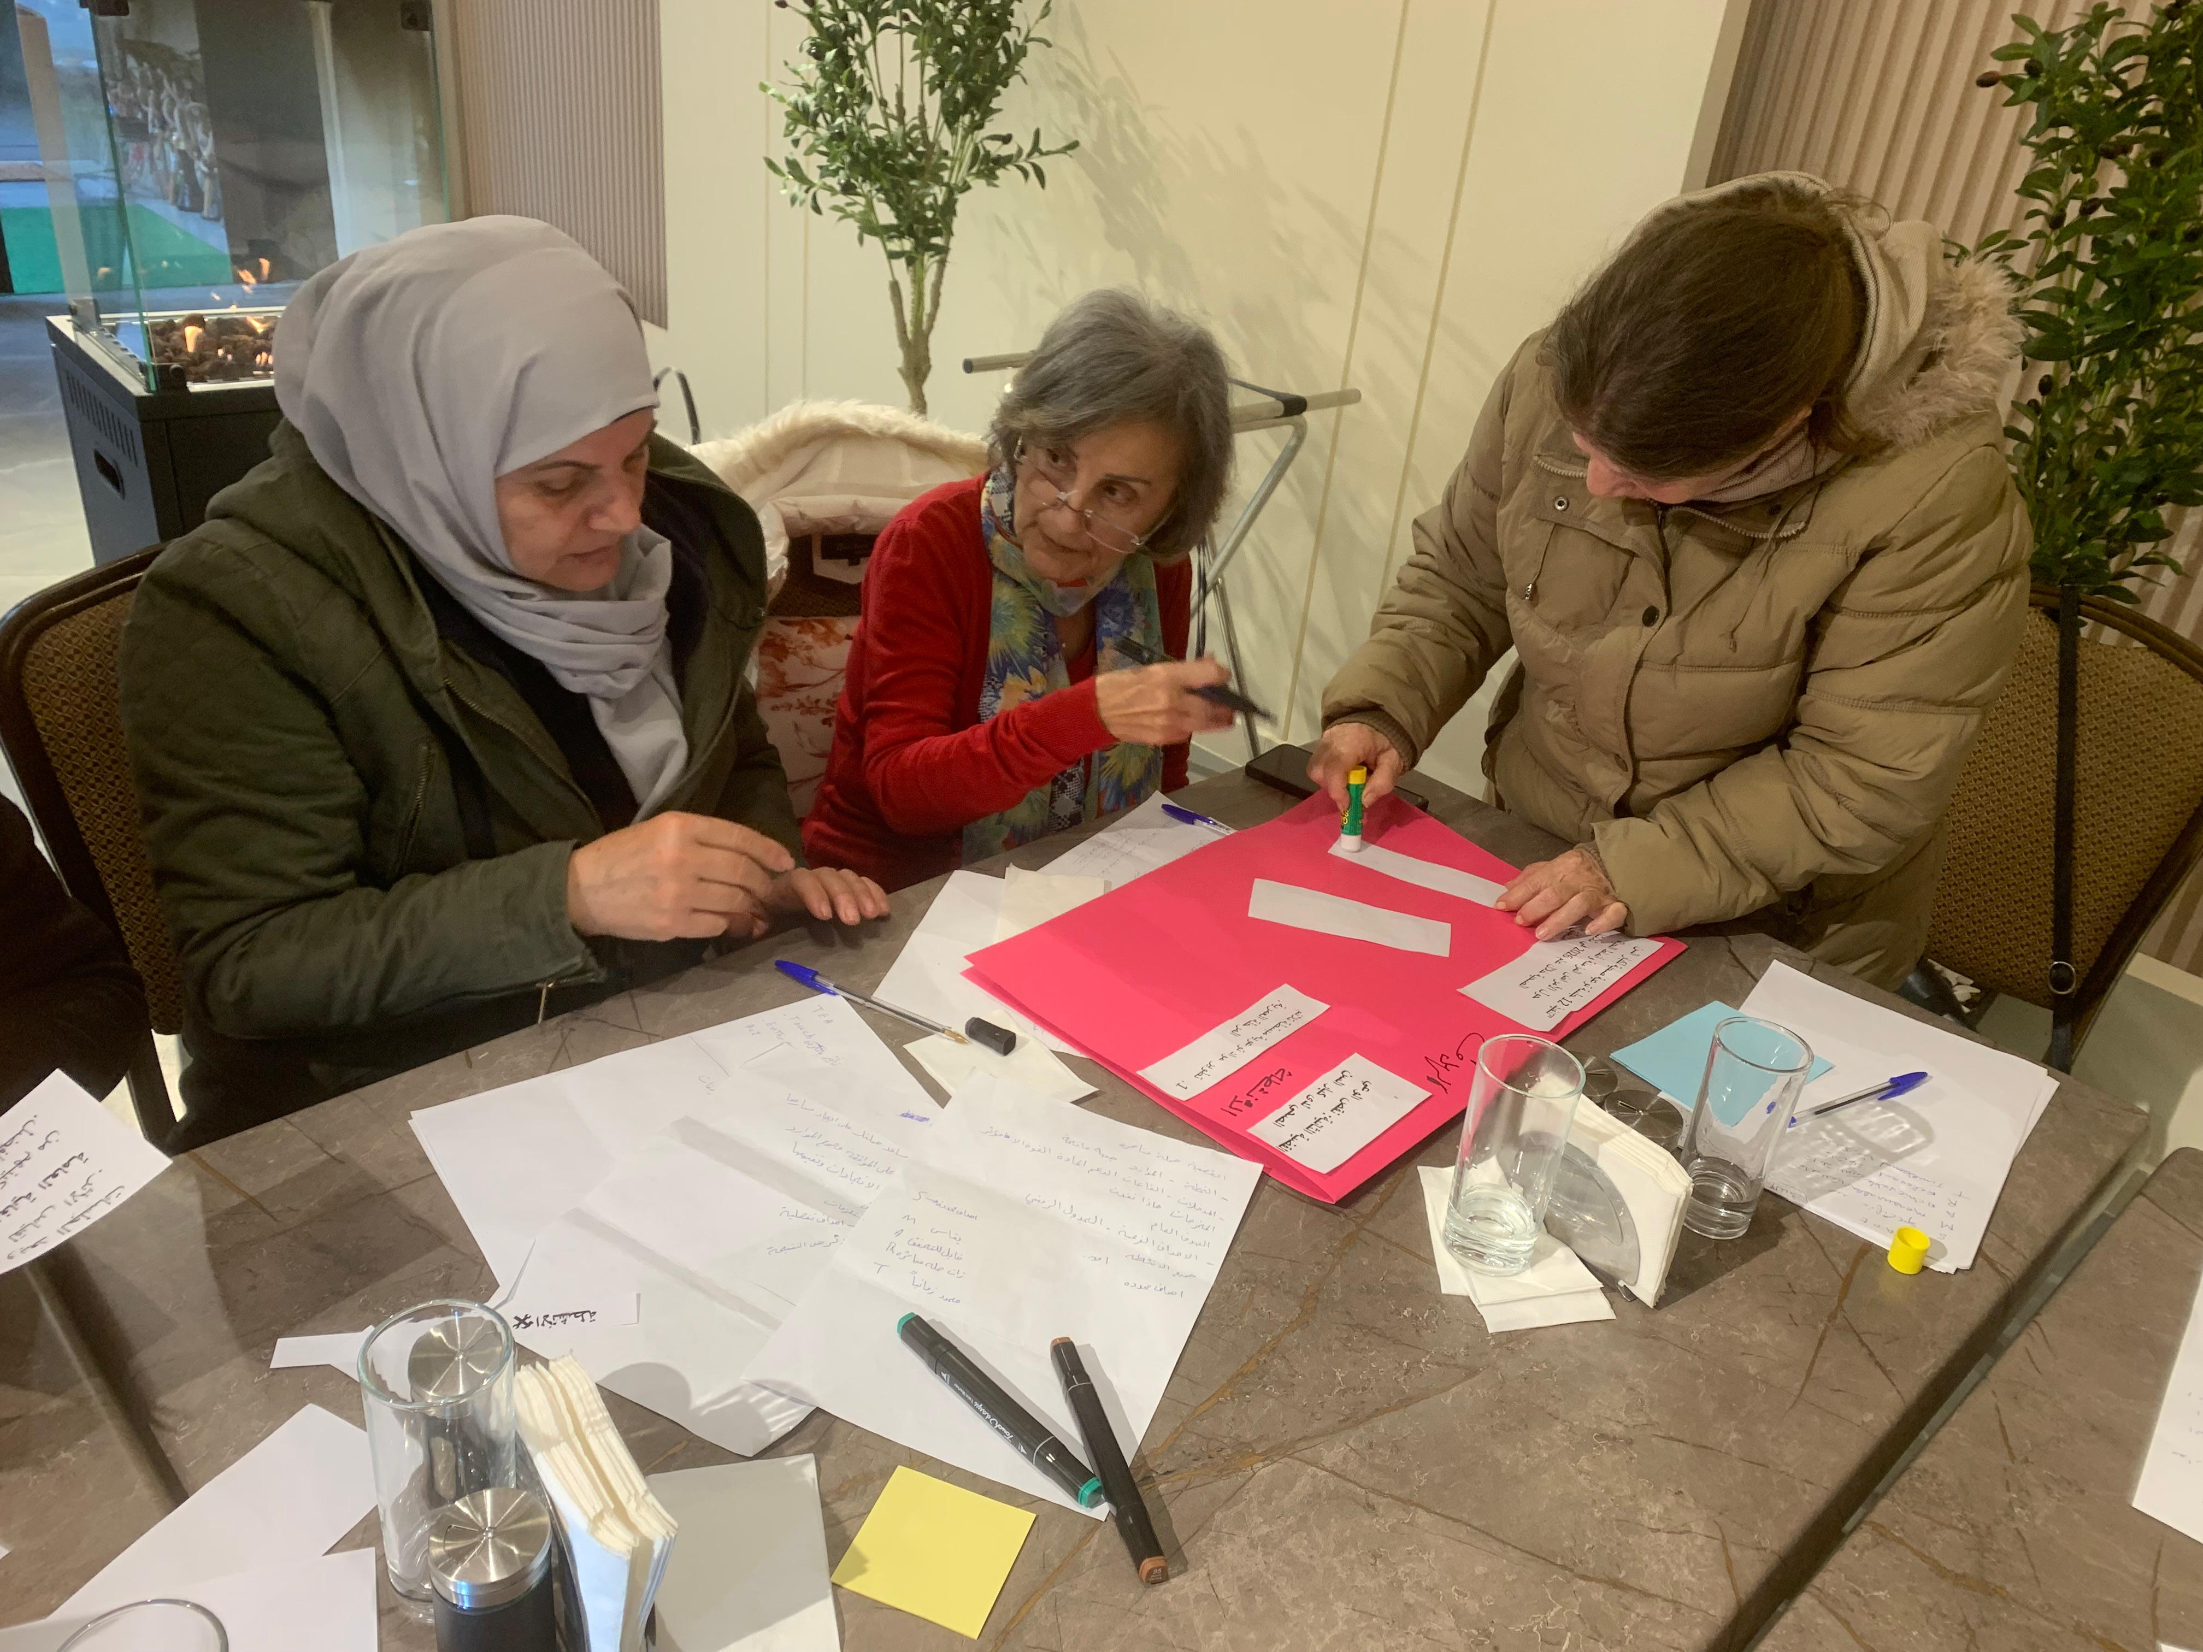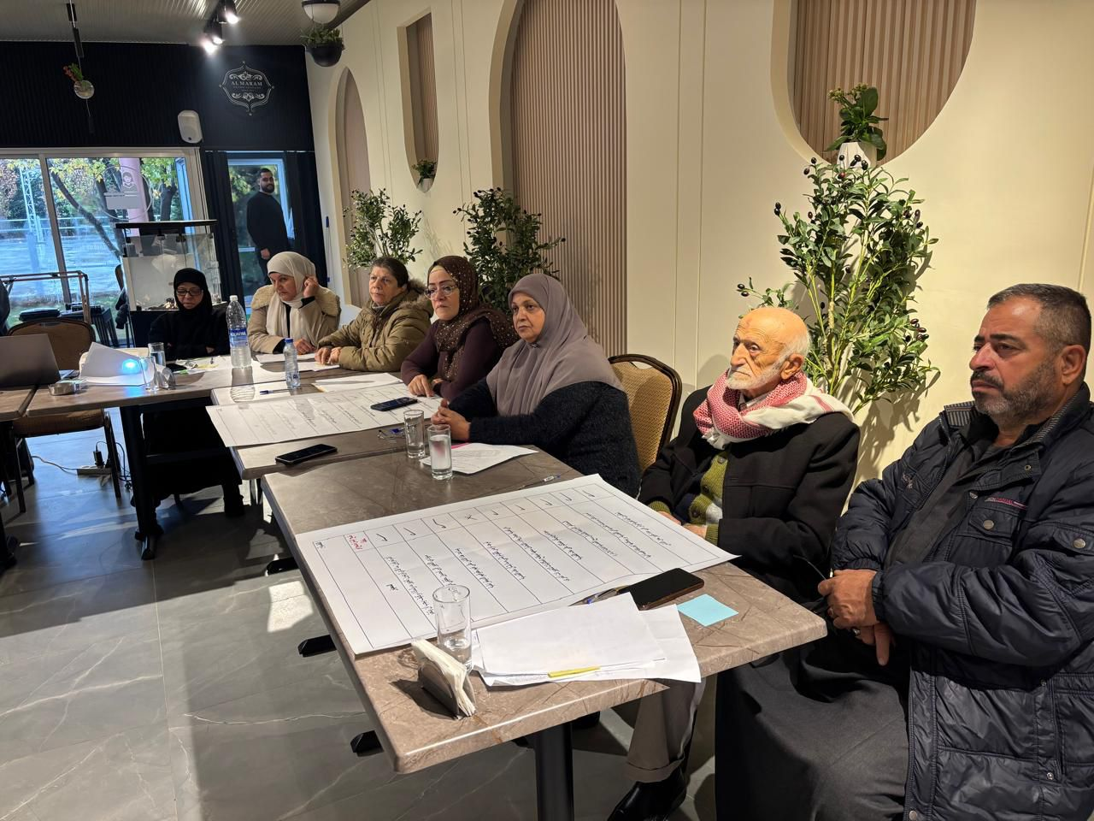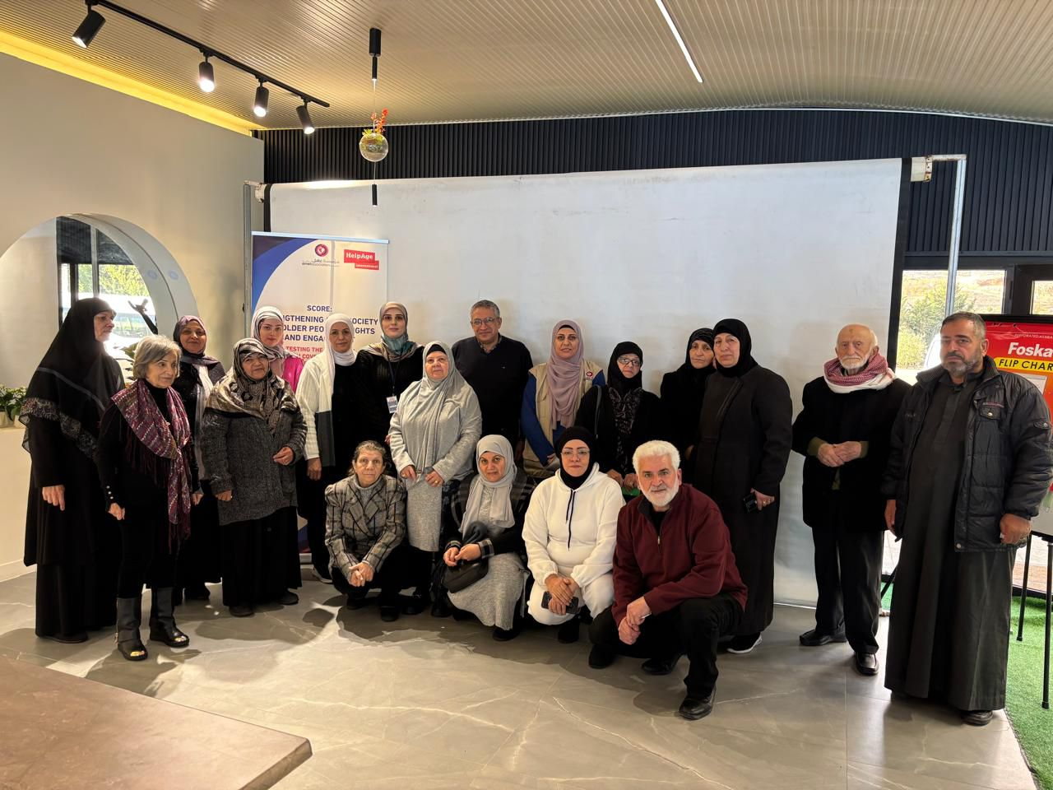

Lessons Learned
Please add a description of the main lessons learned
A key lesson from Year 1 is that strong foundations are essential before moving into larger-scale advocacy and accountability work. The OCA, Ageing Unit strategic planning, Advisory Group ToR, climate resilience analysis, and UHC toolkit testing all contributed to building the institutional and evidence base needed for stronger action in Year 2.
A second lesson is that older people’s participation requires deliberate facilitation and accessibility measures. The UHC training showed that older people can engage meaningfully in advocacy when materials are simplified, delivered in Arabic, paced appropriately, and supported through transport, breaks, storytelling, and participatory methods. These adaptations will be important for future consultations, campaigns, and policy dialogues.
A third lesson is that adaptive management is essential in fragile and conflict-affected contexts. The escalation in Lebanon required Amel to adjust timelines, move activities to Year 2, and prioritize safety and meaningful participation over rigid implementation sequencing. This flexibility helped preserve programme quality and ensure that activities are not implemented in ways that could expose older people or staff to additional risk.
A fourth lesson is that SADDD and MEAL systems need to be strengthened further. While several activities collected useful disaggregated data, gaps remain in systematic age and disability data across all activities. The OCA identified institutional MEAL strengthening and SADDD mainstreaming as priorities for future capacity development.
Sustainability
The sustainability of SCORE Year 1 results is strongly linked to the institutionalization of Amel’s Ageing Unit as a national hub for ageing in Lebanon. The Unit’s strategic planning process, Advisory Group ToR, evidence generation work, and coordination role provide a foundation that extends beyond the project lifecycle. These elements strengthen Amel’s ability to convene stakeholders, generate evidence, support capacity strengthening, and advocate for older people’s rights over the longer term.
The OCA process also contributes to sustainability by identifying organizational priorities that can strengthen Amel’s systems beyond SCORE. Priorities such as internal communication, safeguarding dissemination, security management, MEAL institutionalization, inclusion mainstreaming, fundraising, advocacy strategy, and external visibility are not limited to one project. They are core organizational capacities that will support Amel’s broader humanitarian and development work.
The climate resilience analysis creates new entry points for integrating ageing into climate, disaster risk reduction, health, and social protection agendas in Lebanon. This product can be used with government actors, CSOs, humanitarian partners, donors, academia, and older people’s groups beyond the Year 1 reporting period.
The UHC training and campaign planning also support sustainability by building older people’s capacity to participate in advocacy and by linking community-level priorities to practical service-level changes. The planned Year 2 campaign actions will further strengthen local ownership by engaging older advocates, PHC actors, municipalities, and national stakeholders around feasible age-friendly improvements.
The Advisory Group will further support sustainability by providing strategic, technical, and operational guidance to the Ageing Unit. Its expected role in reviewing strategy, tools, research, curricula, advocacy campaigns, and learning will help ensure that Amel’s work on ageing remains evidence-based, inclusive, participatory, and aligned with both local priorities and international standards.
Overall, Year 1 strengthened the foundations for a more sustainable ageing agenda in Lebanon. While several activities were moved to Year 2 due to the escalation in Lebanon, the investments made in institutional capacity, evidence, older people’s participation, and strategic planning provide a strong basis for continued action and policy influence.

