## **Annual Report for the Dutch Ministry of Foreign Affairs (MFA) — Tech2Peace (T2P)**

**October 2023 — September 2024**

**Introduction**

This report marks the successful completion of the first year of the "Multiplying and Scaling the Impact" project, a four-year initiative generously supported by the Dutch Ministry of Foreign Affairs (MFA). This project is jointly implemented by Tech2Peace (T2P) and 50:50 Startups, with Tech2Peace serving as the lead implementer. Together, we aim to strengthen a resilient and sustainable cross-border community of young Palestinians and Israelis who engage in peacebuilding, cooperation, and professional development in the high-tech and entrepreneurial sectors.

The timing of this year's programming, starting in October 2023, coincided with the outbreak of an unprecedented war. The situation in the region created immediate and significant challenges for cross-border collaboration, particularly between our two primary constituencies—Palestinians and Israelis. Despite this, both Tech2Peace and 50:50 StartUps demonstrated extraordinary adaptability and commitment to the mission, responding swiftly to the realities of the conflict. With the war escalating, the movement of people across borders became increasingly restricted, and traditional ways of engagement were no longer viable. But instead of halting progress, this adversity inspired us to innovate and adapt, ensuring that our vision of fostering cooperation and understanding remained intact.

In response, we immediately pivoted to a hybrid model, blending online programming that could include all members of our community, regardless of their location, with in-person meetups across various local hubs (Tel Aviv, Jerusalem, Haifa, and the West Bank), as well as first ever international seminars. This flexibility allowed us to continue our mission even under the weight of ongoing conflict. The fact that participants continued to engage with the program, even in such trying circumstances, is a testament to the strength and resilience of our community. They showed up—sometimes with frustration, sometimes with anger, but always with the willingness to engage, challenge, and ultimately learn from one another, much like true friends and family do in times of hardship. Their commitment demonstrated that, even in the most difficult moments, the desire for connection and mutual understanding is alive and well.

The overarching goal of this initiative is to cultivate a network of peacebuilders and changemakers who embody the possibilities of positive cooperation between the two sides. Through a combination of high-tech and entrepreneurial training, dialogue and conflict resolution, and ongoing alumni engagement, participants not only build technical skills but also foster meaningful cross-cultural relationships. This initiative is designed to deepen understanding and trust, ensuring that beneficiaries become leaders, advocates, and role models for cross-border cooperation in their personal and professional lives.

Over the course of the first year, both Tech2Peace and 50:50 Startups implemented diverse, impactful activities that collectively engaged over 420 beneficiaries. Both organizations played complementary roles to achieve the program’s objectives. This report introduces both partners and highlights the contributions each has made throughout the year. As the lead implementer, Tech2Peace has taken charge of the majority of activities, ensuring alignment with the objectives set forth in the grant agreement.

The activities this year included seminars, bootcamps, workshops, and community meetups, providing opportunities for professional growth and meaningful dialogue. While the project is committed to achieving an equal balance of participation between Arabs and Jews, and between men and women, this year’s beneficiaries included 227 Jewish participants, 193 Arab participants, 234 men, and 186 women. Among the Palestinian participants, 39% are citizens of Israel, 31% are from the West Bank, and 30% are from East Jerusalem. This demographic breakdown reflects ongoing efforts toward inclusivity and equal representation.

The first year, however, presented significant challenges due to the ongoing war and heightened tensions in Israel and the region. One of the primary obstacles was the difficulty Palestinians from the West Bank faced in obtaining permits to attend activities inside Israel. In response, Tech2Peace adapted by shifting part of its programming online and finding alternative solutions for in-person engagement. To ensure Palestinian participation, we conducted seminars in Cyprus, a neutral location that allowed both West Bank Palestinians and East Jerusalemites to attend. This decision was crucial for achieving the program’s goals, as Cyprus provided the most viable option in terms of visa accessibility, geographical location, and cost. It also created a safe and inclusive space for meaningful interactions between Jewish and Palestinian participants.

To maintain transparency and accountability, Tech2Peace has provided regular updates on the progress of activities and has fulfilled all financial and budgetary reporting requirements throughout the year. This narrative report provides a comprehensive overview of the achievements, challenges, and lessons learned during Year 1, offering a detailed account of program implementation and its alignment with the project’s objectives.

Looking ahead to Year 2, the situation remains uncertain, but we are fully prepared to adapt as needed. Our plan includes hosting binational activities in Area C, specifically in Beit Jala, to facilitate participation from both sides. Additionally, we are organizing another seminar in Cyprus in February and planning Ramadan events in Area C to ensure meaningful engagement despite the logistical challenges. We remain committed to overcoming these barriers and ensuring that Palestinian participants, regardless of their location, can fully take part in the program.

**Key Objectives**

Drawing from the jointly approved proposal and subsequent amendments, the following key objectives guided our work in Year 1:

* **Resilience and Community Building**: Strengthening the community of peacebuilders by fostering meaningful relationships, providing platforms for ongoing interaction, and addressing emerging needs in response to the dynamic political landscape.
* **Professional Development and Employability**: Equipping participants with technical skills, entrepreneurial knowledge, and access to employment pathways that enhance their economic and career prospects.
* **Sustainable Impact and Leadership**: Building a self-sustaining community where alumni take on leadership roles in activities, fostering a cycle of engagement that extends beyond program participation.

### **Key Achievements**

* **Activities Delivered as Planned**: T2P and 50:50 Startups jointly implemented the activities agreed upon with the donor, including:
  + **T2P Activities**:
    - 1 Classic Seminar Abroad
    - 1 Advanced Weekend
    - 2 Program Days
    - 19 Community Meetups
  + **50:50 Activities**:
    - 18 Workshops at Azrieli College Pre-Acceleration Program
    - 26-Session Bootcamp at the Socialtech Lab in Cyprus
* **Responsive Adaptation**: Amid an evolving political context and following the October 7 events, both organizations adapted their approaches. T2P shifted some in-person programs to neutral international locations and supplemented in-person programming with emergency dialogues and community well-being sessions. Meanwhile, 50:50 integrated conflict resolution and dialogue-focused sessions into their professional training workshops and bootcamps to address the unique challenges faced by participants.
* **Community Support and Emotional Resilience**: Recognizing the heightened stress experienced by participants, T2P offered specialized therapist-led support sessions, and 50:50 incorporated decision-making and dialogue workshops to foster emotional well-being and strengthen participants’ resilience.
* **Leadership and Sustainability**: Alumni from both organizations played a central role as facilitators, mentors, and organizers, furthering the sustainability of the program. This collaboration laid the groundwork for a long-term, self-sustaining alumni network that spans both organizations’ communities.

### **Commitment to Transparency and Accountability**

Tech2Peace and 50:50 Startups ensured continuous communication with the donor throughout the year, sharing timely updates and securing approval for all necessary modifications. The program’s financial and operational management adhered to rigorous standards of accountability, and the delivery of activities remained fully aligned with the goals and deliverables set forth in the original agreement.

This report reflects on the milestones achieved during Year 1, demonstrating the impact of the Dutch MFA’s investment and the unwavering dedication of both organizations to fostering a resilient community of peacebuilders. We look forward to building on this momentum in Year 2 as we continue to support participants and alumni in their journey toward lasting peace, understanding, and professional growth.

**Activities Implemented**

Throughout the first year of the "Multiplying and Scaling the Impact" project, Tech2Peace and 50:50 Startups implemented a diverse range of activities designed to foster resilience, community-building, and professional development in the face of adversity. The activities included seminars, community meetups, workshops, and mentoring opportunities—each one an opportunity to learn, engage, and grow as individuals and as a community. Together, these events created dynamic, meaningful spaces where participants not only developed technical skills but also built deeper relationships, laying the foundation for a network of cross-border cooperation and trust.

Given the complexities and challenges of the year—particularly the ongoing war and restrictions on movement—the project quickly adapted to meet the needs of the community. We introduced a hybrid model, blending online programs with in-person engagements. This was not just a logistical decision; it was a response to the collective desire within the community to come together. After the first month of Zoom-based programming, participants expressed a strong need to meet face-to-face, to rebuild the connections that are so essential in times of crisis. They felt the weight of isolation and yearned for the camaraderie and support that only in-person meetings can offer.

Listening to this call, Tech2Peace moved swiftly to resume in-person meetups, strategically organizing local events in key areas—Tel Aviv, Jerusalem, Haifa, and the West Bank. These local hubs were designed not only to bring people together but to ensure accessibility for those who were unable to travel due to the ongoing war. By focusing on a local model, we made sure that community members from both sides could engage in a safe and meaningful way, even during times of heightened tension and mobility restrictions.

The spread of these activities was intentional, reflecting the community’s diverse needs and challenges, particularly in times when borders and movement were more restricted than ever before. These local meetups were more than just logistical solutions—they were a lifeline for participants who were seeking connection, support, and a space to process their emotions and experiences during a period of intense uncertainty. Through these gatherings, we saw firsthand how the community rallied together, finding strength in each other, and proving that, even under the most difficult circumstances, the need for dialogue and collaboration remains strong.

As we moved forward with our programming, every activity—whether virtual or in person—was designed with the goals of strengthening participant engagement, building technical capacity, and deepening connections within the community. The resilience of this community, and their unwavering commitment to the cause, stands as a testament to the power of cross-border cooperation, even in the most challenging of times.

**Beneficiary Reach**:

* **Tech2Peace**: Engaged a total of 353 beneficiaries through its diverse programs and activities. This group included 159 women and 194 men, with a demographic breakdown of 208 Jewish participants and 145 Arab participants.
* **50:50 Startups**: Engaged 67 participants through its workshops and bootcamps, comprising diverse backgrounds that mirrored the project’s goals of inclusivity and cross-border collaboration.
* **Total Reach**: 420 beneficiaries participated in activities delivered by both organizations, reflecting the significant impact of the joint initiative.

**Impact Highlights**

* **Skill Development**: Participants from both organizations gained advanced technical and entrepreneurial skills, but the impact went far beyond professional development. These new competencies empowered participants to envision and pursue their careers with renewed confidence, knowing that they were not only learning cutting-edge skills but also strengthening their ability to contribute to a more cooperative, peaceful future. Whether it was mastering the latest tech innovations or refining their entrepreneurial ideas, each skill gained was a step towards building bridges, not just careers.
* **Community Building**: In a year defined by challenges and uncertainty, the power of community became even more evident. Through every seminar, every workshop, and every online meeting, the program became a space for mutual understanding, trust, and dialogue between Israelis and Palestinians. What began as a shared desire for understanding and collaboration blossomed into a resilient and supportive community—one that continues to grow, adapt, and thrive. These activities weren't just about learning skills; they were about creating meaningful relationships, breaking down barriers, and fostering the kind of trust that transcends borders and conflict. The bonds formed within this community have proven to be stronger than the forces that divide, showing that even in the most difficult times, people yearn for connection, understanding, and a better future together.
* **Leadership and Innovation**: The program’s impact didn't stop at skill development and community-building—it sparked leadership and innovation at a grassroots level. Alumni, empowered by the knowledge and experiences they gained, initiated communication that crossed boundaries and brought people together in ways that had never been imagined before, for such challenging and violent times. These projects weren’t just about advancing individuals; they were about advancing the cause of peace, innovation, and mutual respect. The alumni network grew stronger, ensuring that the seeds planted during this project would continue to grow, creating a lasting ripple effect that will sustain and scale the outcomes for years to come. Through their leadership, our alumni are shaping the future, driving innovation, and ensuring that the vision of a cooperative, cross-border community continues to flourish long after the project’s conclusion.

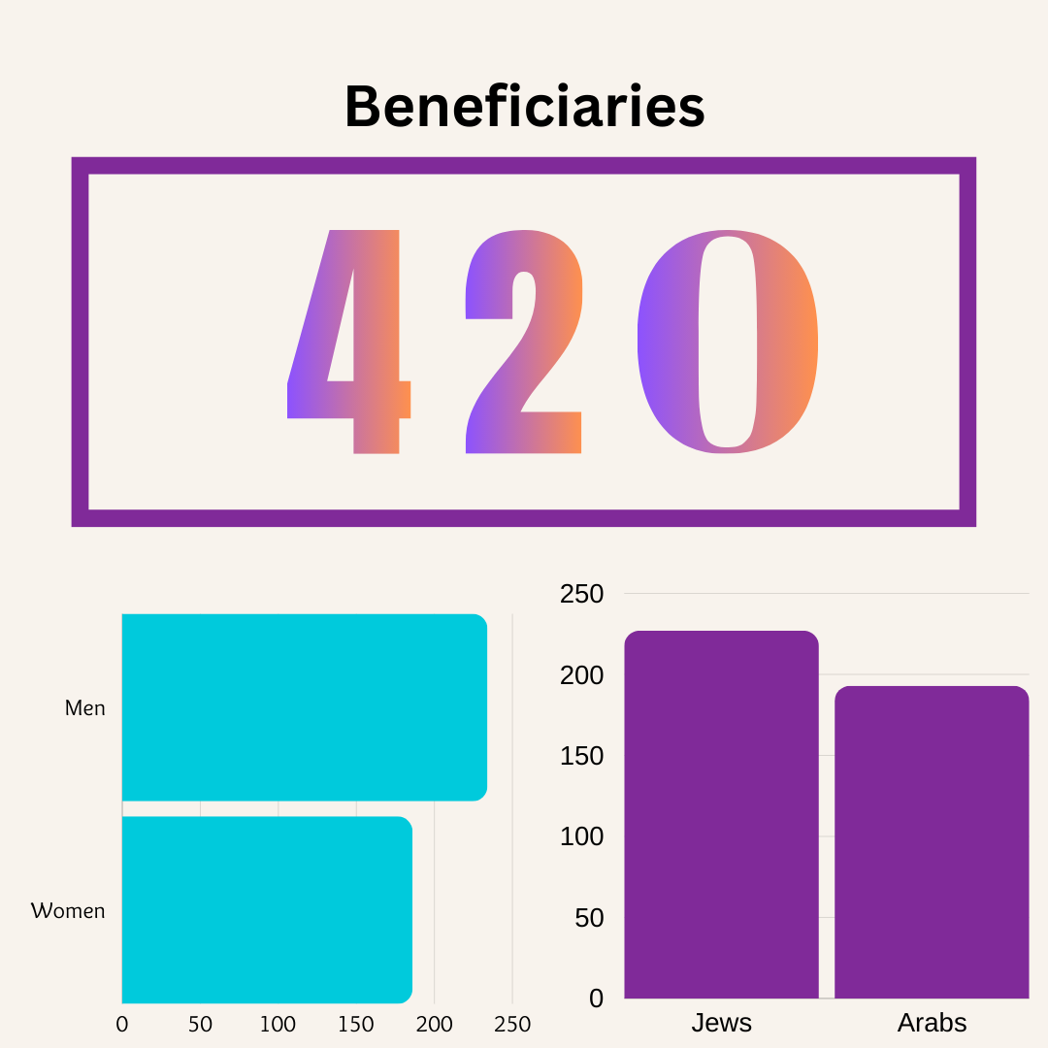

This collaboration between Tech2Peace and 50:50 Startups marked a shining moment of mutual support, showcasing the immense power of partnership in achieving the project’s goals. Tech2Peace, having organized and gained valuable insights from the seminars it held in Cyprus in February and March 2024, generously shared the knowledge, connections, and experiences it had gained with 50:50 Startups. This exchange of resources and expertise allowed both organizations to come together and launch additional seminars in Cyprus, but this time with an even more exciting twist.

For the first time ever, the two organizations brought participants together for a shared hackathon within the seminar framework, hosted by a partner organization - The SocialTech Lab. This hands-on, collaborative experience was a true milestone in cross-border cooperation, as Israeli and Palestinian participants worked side-by-side to solve challenges and innovate together. The hackathon not only provided a practical space for skills development but also fostered a deeper sense of camaraderie and teamwork, proving that, despite the geopolitical divisions, cooperation between these two communities is not just possible—it’s powerful and transformative.

By integrating their efforts, Tech2Peace and 50:50 Startups demonstrated the profound potential of collaborative, cross-border programming. Together, they created a space for participants to not only develop professionally but also to engage in meaningful, real-world cooperation that lays the foundation for a future of mutual respect, shared innovation, and lasting peace. This collaborative success was a testament to the power of working together toward common goals, highlighting the transformative impact that cross-border partnerships can have on building a more connected and understanding world.

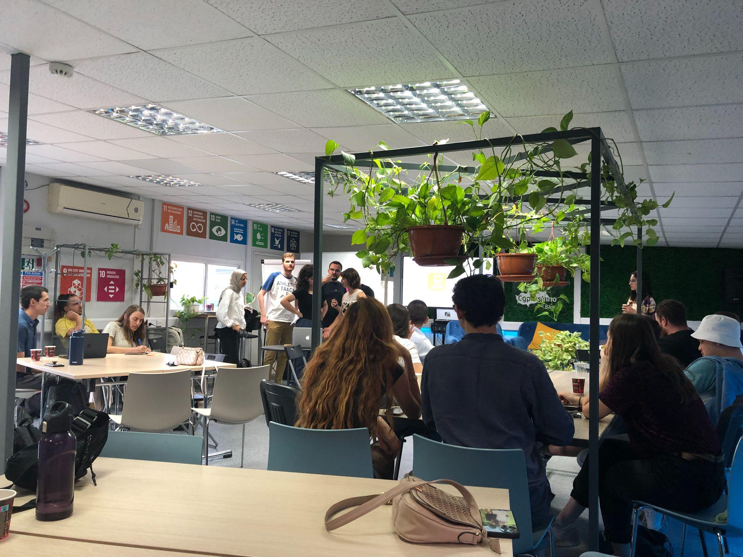

*(all photos in this report for internal use only, not for distribution)*

Below is a detailed overview of the activities implemented within this year - Tech2Peace Part:

**1. Seminar Abroad**

* **Date**: October 2024
* **Beneficiaries**: 20 participants (10 women, 10 men; 10 Jews, 10 Arabs)
* **Description:** The seminar provided an intensive residential program held in a neutral international location, offering an immersive and transformative experience. It seamlessly combined high-tech skills training with facilitated dialogue sessions, creating a safe and empowering space for participants to not only develop professionally but also to build trust and foster mutual understanding.

In response to the current wartime reality, the seminar's dialogue content was thoughtfully updated to reflect the ongoing conflict, ensuring that participants could address the challenges and complexities they face in their daily lives. Workshops, such as the narratives session, were updated to include discussions around the war and its impact, allowing participants to share and reflect on how the conflict had shaped their personal and collective histories. Despite the heavy emotional weight, the seminar provided a platform where people were genuinely open to understanding the pain of the other, offering a glimmer of hope that, even in times of division, empathy and connection remain possible.

At the same time, the focus on entrepreneurship and tech remained unchanged, offering a sense of continuity and normalcy amidst the chaos. These sessions felt "normal" in the best sense of the word—participants engaged in the same forward-thinking, solution-oriented discussions they always have, showing that, despite the challenging realities around them, people are still driven by a shared desire to innovate, collaborate, and create a better future together. This balance between confronting the difficult present and focusing on the opportunities of the future served as a powerful reminder that, at our core, we are all people—working together, growing together, and striving to make a meaningful difference in the world.

**2. Program Days**

* **Dates**: August 23, 2024 (Checkpoint Tour); September 15, 2024 (Hustlers Workshop)
* **Beneficiaries**: 17 participants across two program days (8 women, 9 men; 5 Jews, 12 Arabs)
* **Description**: These days were dedicated to focused workshops and invaluable industry exposure, offering participants unique opportunities to gain insights into the high-tech world and expand their professional horizons.

The **Checkpoint Tour**, led by Jeremy Kaye and Othman Kharoubi of CheckPoint, provided a behind-the-scenes look at the headquarters of Checkpoint, one of the leading companies in the high-tech sector. This tour not only introduced participants to the company's cutting-edge work but also opened their eyes to the range of career pathways available within the industry. What made this experience particularly meaningful was the shared perspective of Jeremy, a Jewish Israeli, and Othman, a Palestinian from East Jerusalem, both working together in these challenging times. Their collaboration exemplified the possibility of building professional relationships across divides, showcasing how cooperation in the high-tech industry transcends borders and differences.

The **Hustlers' Workshop Series** was another core element, a series of online workshops delivered by various industry experts. These sessions covered key topics such as investment strategies, personal finance, and entrepreneurial development, with the goal of empowering participants to increase their financial independence and seize new opportunities. The workshops also fostered a collaborative spirit among participants, encouraging them to share knowledge, exchange ideas, and work together to unlock their potential in the high-tech and entrepreneurial sectors. These sessions were not just about learning technical skills—they were about creating a sense of empowerment, opening doors to new possibilities, and demonstrating the power of shared knowledge and collective action in building a brighter future.

**3. Advanced Weekend**

* **Date**: February 1-3, 2024
* **Beneficiaries**: 39 participants (12 women, 27 men; 19 Jews, 20 Arabs)
* **Description**: The first in-person dialogue weekend for Tech2Peace (T2P) since October 7 was held in Jerusalem and centered on Arab-Jewish relations, specifically exploring the dynamics within the T2P community both before and after the events of October 7. Despite the profound difficulty of engaging in dialogue during such a turbulent time, the weekend provided a crucial space for participants to come together, engage in meaningful discussions, and share their personal experiences.

This weekend was a testament to the strength and resilience of the T2P community. While tensions were high and emotions raw, the participants demonstrated exceptional courage and understanding in listening to each other's perspectives, despite the deep divisions caused by the ongoing conflict. The dialogue was difficult, but it was also a powerful expression of the community’s commitment to staying connected, even in the most challenging of circumstances. It was a moment where individuals from both sides showed a willingness to hear the pain of the other, holding space for empathy and mutual respect. The weekend ultimately reaffirmed that, even in times of hardship, the bonds within the community remain strong, and the pursuit of understanding and cooperation endures.

**4. Community Meetups** The **Community Meetups** were a cornerstone of Tech2Peace’s community-focused programming, offering participants and alumni ongoing opportunities for engagement and peer support. These local events, hosted by different community members at their request, provided an essential space for individuals to meet in person—especially in a time when movement was extremely challenging in both Israel and Palestine due to the wartime reality. By making the meetups local, we made them more accessible, allowing alumni to gather in familiar settings without the added barriers of travel. The importance of these meetups went beyond networking and professional development; they were about creating space for community members to “just” hang out, people to people. In doing so, we helped to de-escalate tensions, providing an environment where participants could see each other as friends rather than foes. These informal gatherings allowed for human connection and understanding to flourish, even amidst the broader struggles around them.

A standout example of these meetups was the **Beit Sahour Program Day**, which focused on reconnecting the West Bank community of T2P. This event was designed to bring participants together to reflect on the historical and cultural significance of Beit Sahour, a town with deep roots in Palestinian history. Through discussions and knowledge-sharing, the program aimed to promote reconnection and healing within the community, helping participants process the challenges they were facing in a post-war reality. The day was a reminder of the strength of the community and the role that shared learning and reflection play in fostering resilience and rebuilding connections in the face of adversity.

Below is a breakdown of the dates, number of beneficiaries, and their demographic distribution by nationality and gender:

|  |  |  |  |  |  |  |  |
| --- | --- | --- | --- | --- | --- | --- | --- |
| **#** | **Date** | **Benef-iciaries** | **Wo-men** | **Men** | **Jews** | **Ara-bs** | **Description** |
| 1 | October 16, 2023 | 24 | 12 | 12 | 14 | 10 | An external expert sharing tips and tools to manage emotions and reactions during times of stress or crisis due to recent events. |
| 2 | October 18, 2023 | 10 | 6 | 4 | 6 | 4 | |  | | --- | | Part of the emergency Zoom dialogue series, done specifically for the seminar. Aiming to connect community members, offer and receive support, and share thoughts and feelings in a safe space. | |
| 3 | October 30, 2023 | 15 | 7 | 8 | 11 | 4 | Part of the emergency Zoom dialogue series, done specifically for a recently completed seminar in Neve Shalom. Aiming to connect community members, offer and receive support, and share thoughts and feelings in a safe space. |
| 4 | November 1, 2023 | 14 | 8 | 6 | 11 | 3 | T2P community gathering |
| 5 | November 1, 2023 | 24 | 10 | 14 | 12 | 12 | Delving into the strategy and thought process of T2P in the current times with T2P CEO. Followed by a Q&A session to encourage open dialogue. |
| 6 | November 2, 2023 | 9 | 2 | 7 | 9 | 0 | T2P community gathering |
| 7 | November 8, 2023 | 16 | 7 | 9 | 9 | 7 | Discussing the next steps for T2P after October 7 with the mentors. |
| 8 | November 21, 2023 | 16 | 8 | 8 | 8 | 8 | A two-part workshop on communicating non-violently: how to communicate more effectively, especially in situations of conflict or disagreement. Led by Marcus Armstrong, an international facilitator. |
| 9 | November 28, 2023 | 14 | 7 | 7 | 7 | 7 | A two-part workshop on communicating non-violently: how to communicate more effectively, especially in situations of conflict or disagreement. Led by Marcus Armstrong, an international facilitator. |
| 10 | January 14, 2024 | 10 | 6 | 4 | 10 | 0 | T2P community gathering |
| 11 | January 31, 2024 | 7 | 4 | 3 | 0 | 7 | Mentor community meeting gathering |
| 12 | February 8, 2024 | 10 | 3 | 7 | 2 | 8 | T2P community gathering |
| 13 | February 19, 2024 | 15 | 8 | 7 | 14 | 1 | T2P community gathering with T2P co-founder who came from abroad |
| 14 | March 15, 2024 | 19 | 8 | 11 | 13 | 6 | T2P community dinner with the aim of connecting new alumni from the latest seminar and bringing them together with other T2P alumni |
| 15 | April 4, 2024 | 31 | 18 | 13 | 23 | 8 | T2P community gathering to say good-bye to Jake, after 5 years with the organization as a volunteer and a paid staff member |
| 16 | May 2, 2024 | 13 | 4 | 9 | 10 | 3 | T2P community gathering |
| 17 | July 8, 2024 | 10 | 2 | 8 | 8 | 2 | T2P community gathering |
| 18 | August 15, 2024 | 10 | 6 | 4 | 7 | 3 | T2P community gathering to specific to the Cyprus seminar in March to rekindle the connections and experiences of the seminar alumni |
| 19 | August 26, 2024 | 10 | 3 | 7 | 0 | 10 | The first meeting of a quarterly committee designed to serve the community by the community itself. The West Bank community faces unique challenges that require input from alumni on how to proceed with events, programs, and support. |

These meetups collectively engaged **277 beneficiaries** (127 women, 150 men), strengthening Tech2Peace’s alumni network while reinforcing the resilience and community focus of the program.

These activities demonstrate the breadth and depth of T2P’s approach to peacebuilding, emphasizing not only technical and professional skills but also emotional well-being, dialogue, and resilience. By fostering meaningful engagement among participants, T2P continues to create a lasting impact within its community of peacebuilders.

Below is a detailed overview of the activities implemented within this year - 50:50 Startups Part:

* **Workshops at Azrieli College Pre-Acceleration Program**
  + **Dates**: May 27, 2024 – July 18, 2024
  + **Number of Participants**: 50
  + **Activities**: 18 workshops were conducted, including 14 focused on professional development topics such as business planning, market research, and innovation strategies. Four workshops emphasized bridge-building and conflict resolution, enabling participants to engage in meaningful dialogue while advancing their entrepreneurial skills.

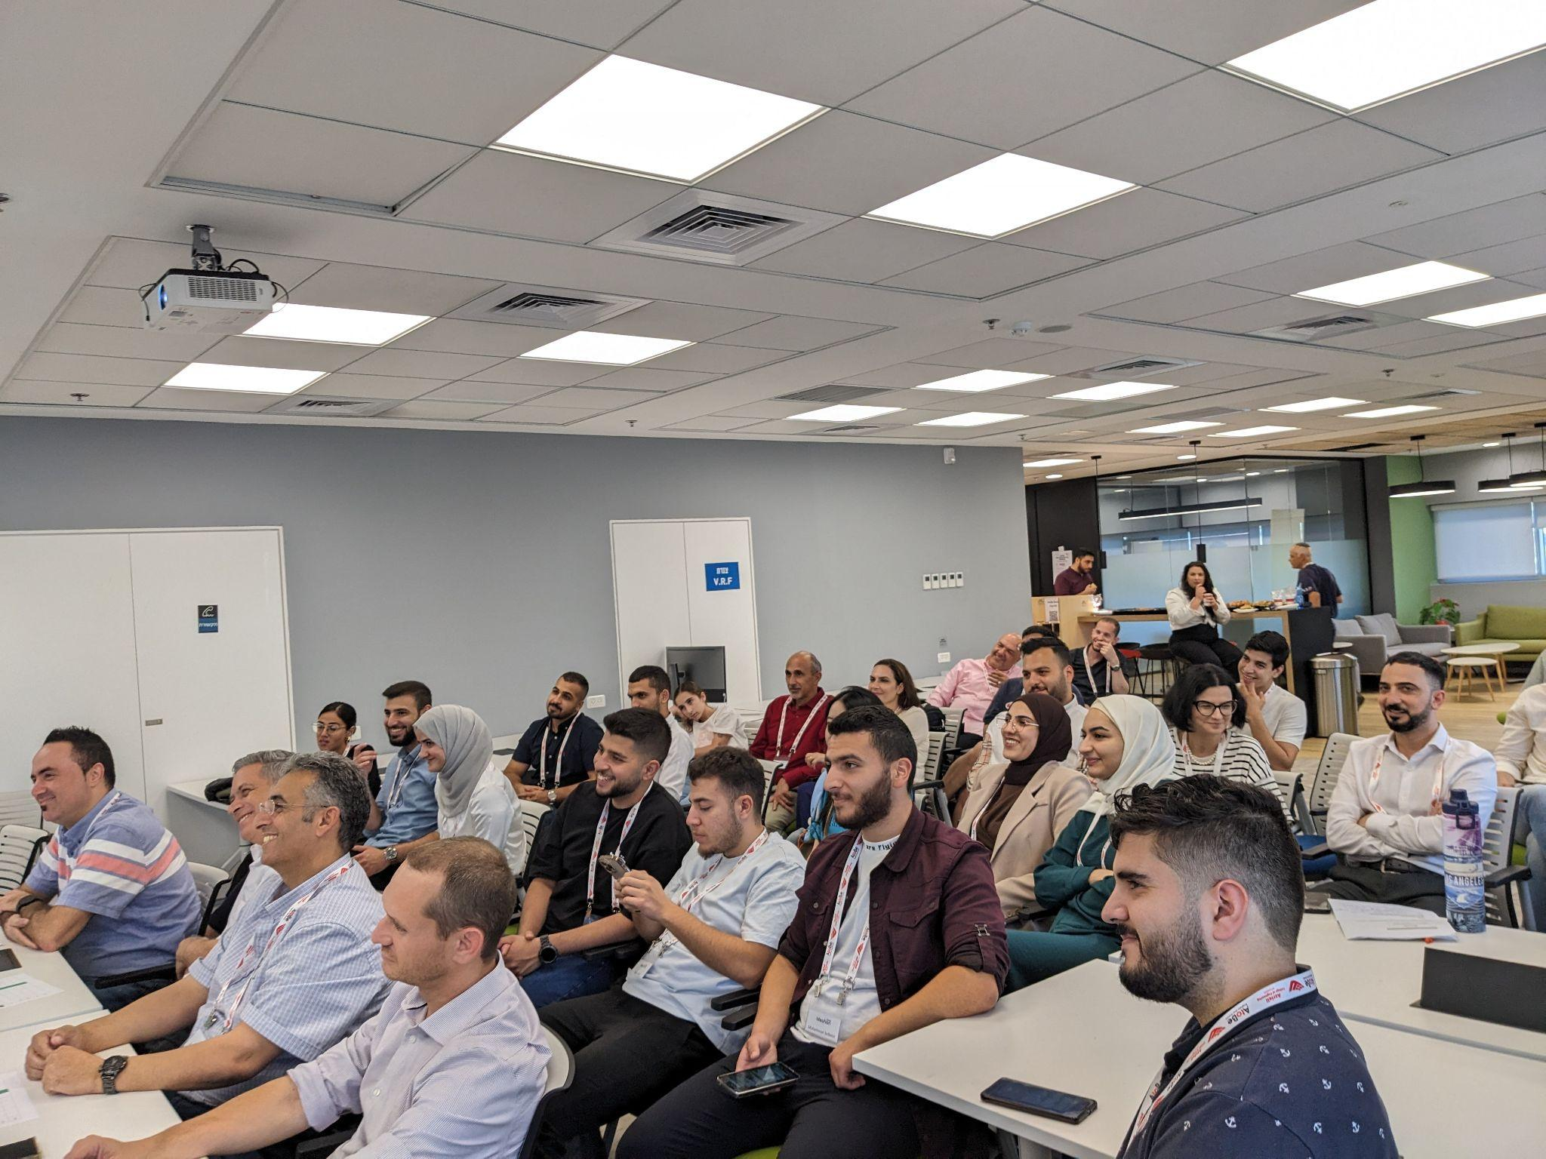

*(all photos in this report for internal use only, not for distribution)*

* **Socialtech Lab Bootcamp in Cyprus**
  + **Dates**: October 28, 2024 – November 10, 2024
  + **Number of Participants**: 17
  + **Activities**: This intensive 26-session bootcamp included 20 professional and business-focused sessions covering scaling strategies, pitching, and venture leadership. Six sessions were dedicated to conflict resolution, ethical decision-making, and fostering dialogue under challenging circumstances.

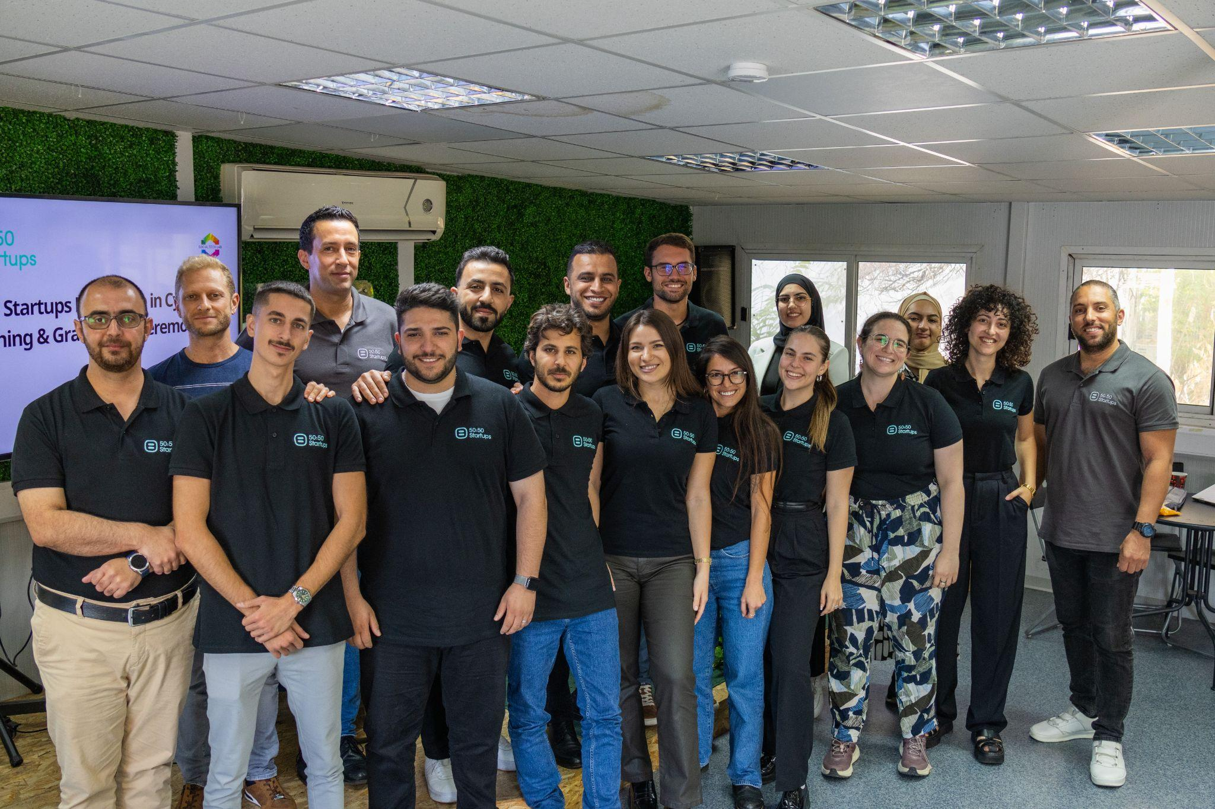  
 *(all photos in this report for internal use only, not for distribution)*

The total number of beneficiaries is 67, which was divided as follows:  
Gender- 40 men, 27 women  
Nationality- 48 Arabs, 19 Jews

### **Progress Towards Goals**

The Theory of Change for the **"Multiplying and Scaling the Impact"** project posits that by providing high-tech and entrepreneurial training under conditions of equal status, alongside conflict dialogue and connections to international companies and capital, young Israelis and Palestinians from diverse backgrounds will be incentivized to cooperate and build deep relationships and mutual understanding.

This process is envisioned to lead to the development of:

* A resilient cross-border community,
* Joint entrepreneurial ventures,
* Professional success for participants.

By demonstrating the benefits of peaceful cooperation, the initiative aims to increase trust in and support for collaborative actions necessary to achieve tangible progress toward a two-state solution.

During the first year, the program laid the groundwork for achieving these ambitious goals. Both Tech2Peace and 50:50 Startups implemented activities aligned with the Theory of Change, equipping participants with the skills and relationships needed to foster mutual trust, professional collaboration, and sustainable impact.  
As the first year of a four-year project, progress has been made towards achieving the four key goals. Below is a focused overview of progress against the 2024 targets for each goal:

**G1: Increase in Belief in Israeli-Palestinian Cooperation**

* **2024 Target**: 90% of beneficiaries report an increase in belief in Israeli-Palestinian cooperation.
* **Progress**: Post-program surveys indicate that 94% of beneficiaries reported an increase in belief in Israeli-Palestinian cooperation.

**G2: Media Visibility**

* + **2024 Target**: 20 media items featuring partners or alumni.
  + **Progress**: Tech2Peace secured 15 media mentions. This outcome reflects the challenges posed by the regional events following October 7. Heightened sensitivities and restrictions around shared society activities made it more difficult to gain media coverage during this period. Despite these challenges, the achieved mentions highlight the program's continued relevance and impact, laying the groundwork for increased visibility in the coming years.

**G3: Social Media Reach**

* + **2024 Target**: Reach of 600,000 people via social media.
  + **Progress**: T2P’s social media campaigns and strategic content reached **201.2K people**. The 600K projection was established long before the war, and the events following October 7 required a shift in priorities. Ensuring the safety of staff and participants became paramount, which led to an intentional reduction in social media activity. While this adjustment directly impacted total exposure, it was a necessary step to safeguard our community. Despite these challenges, participation in sessions remained strong, highlighting the significant need for and impact of the program. Moving forward, T2P will refine its strategies to balance safety concerns with outreach efforts.

**G4: Engagement with Key Leaders**

* + **2024 Target**: 40 key leaders in government and tech engaged.
  + **Progress**: 28 key leaders in government and technology were engaged through events, workshops, and collaborative initiatives. The 2024 target was to engage 40 key leaders in government and technology. This year, 28 key leaders were engaged through events, workshops, and collaborative initiatives. The shortfall reflects the challenges posed by the ongoing war, during which attention from government and tech leaders shifted to immediate crisis management. Additionally, program adaptations and revisions to align with the current context became a priority. Despite this, significant progress was made in fostering meaningful connections, laying the groundwork for expanded engagement in the coming years.

**Impact Stories and Testimonials**

Throughout the year, participants shared powerful reflections on their experiences in the "Multiplying and Scaling the Impact" project. These testimonials highlight the transformative impact of the initiative across both Tech2Peace and 50:50 Startups programs, showcasing how participants developed technical skills, deepened cross-cultural understanding, and formed meaningful connections.

#### **Testimonials from Tech2Peace’s October Seminar:**

* "It allowed me to feel hope, helped me reconnect with my desire to take part in the entrepreneurial world, and made me realize I want to be a facilitator. It connected me to beautiful people from very different backgrounds. It was a supportive environment to meet people and create friendships."
* "The opportunity to meet people from diverse backgrounds with diverse perspectives and build meaningful connections. To have many of my assumptions, from both sides, challenged and to get a fuller understanding of the conflict."
* "I found it really interesting to have discussions and dialogue with the 'other side' and to learn more about lived experiences that differ greatly from mine. I also enjoyed the tech classes and felt they were a good introduction to new, unfamiliar tech skills that I hope to continue into the future."
* "It is a great framework and a well-guided program. The mix between tech and dialogue is very effective, and the low threshold in tech is great for people who are curious but inexperienced in the field."
* "The program helped me express myself and discover new things about me and the people around me."
* "It was thought-provoking and gave me a lot of things to think and learn more about. It made me curious to hear more from the other side. It was inspiring to meet new people from different backgrounds and get to know them deeply."

#### **Testimonials from 50:50 Startups Programs:**

* "Participating in the Azrieli cohort was a professional milestone. The opportunity to learn from peers and industry experts was invaluable."
* "The Cyprus program offered an enriching environment for professional growth. It was a place where we could exchange ideas and reach new heights in our entrepreneurial journey."
* "50:50 Startups provided a dynamic platform for professional development. The experience has been instrumental in shaping our career trajectory and expanding new networking environments."

These testimonials reflect the program’s success in creating a safe, engaging, and inspiring environment that fosters professional growth, meaningful dialogue, and lasting connections. Visuals from the seminars and bootcamps further highlight the participants’ engagement and the program’s impact.

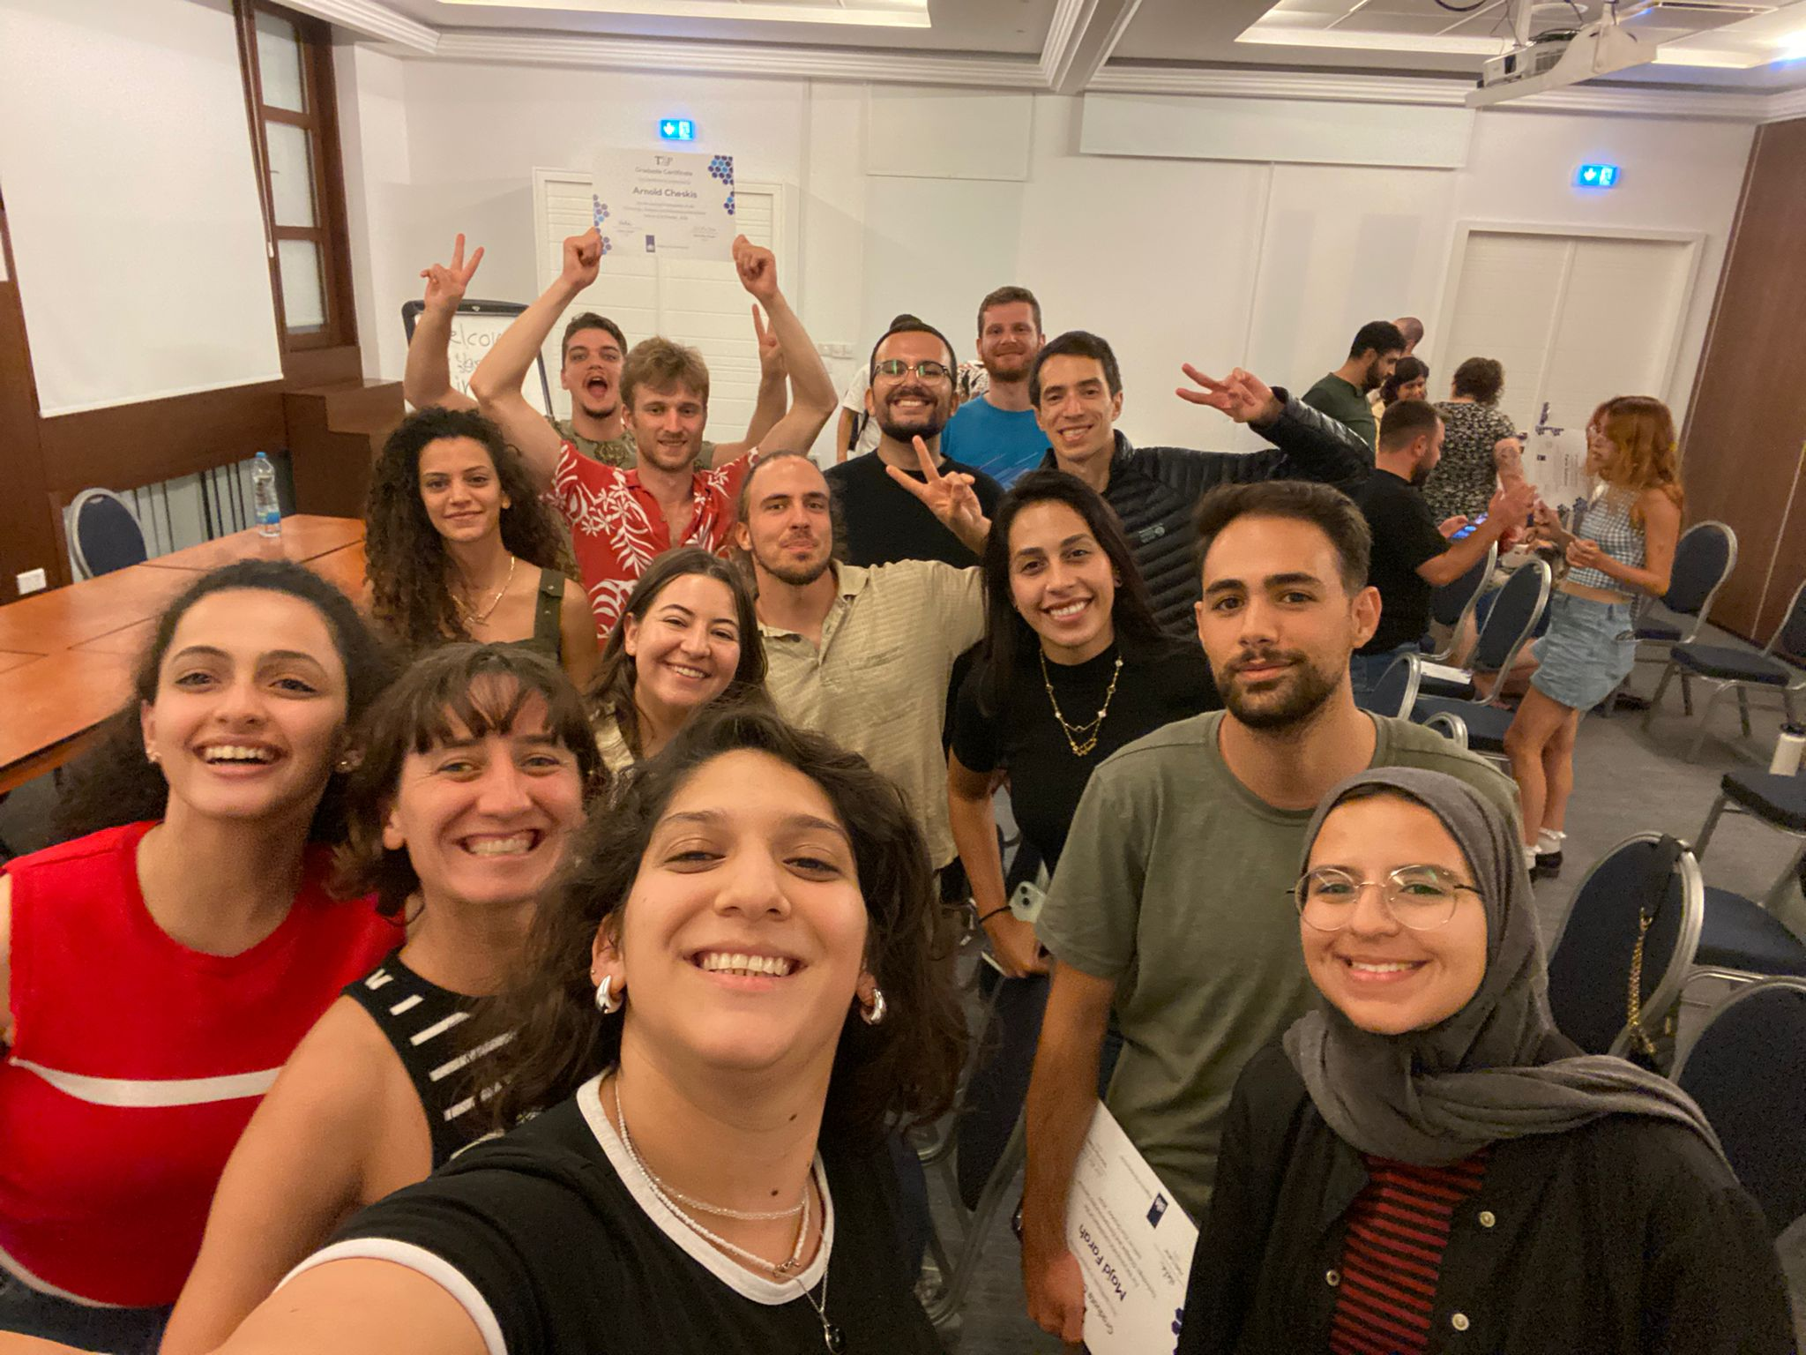  
*(all photos in this report for internal use only, not for distribution)*

**Next in the Horizon**

As we move into the second year of the *Multiplying and Scaling the Impact* project, Tech2Peace remains committed to fostering meaningful collaboration and dialogue between Palestinian and Israeli participants despite ongoing regional challenges. Our programming for Year 2 builds on the lessons learned in the first year while incorporating flexible and adaptive approaches to ensure continued engagement.

One of the key components of our plan is the international seminar in Cyprus, scheduled for February 2025. Given the success of previous seminars held there, Cyprus remains the most viable neutral location that allows participation from both West Bank Palestinians and East Jerusalemites, overcoming the logistical and permit challenges they face. This seminar will provide a secure and inclusive space for deepening trust, building professional skills, and strengthening long-term relationships among participants.

In addition to the Cyprus seminar, we are planning Ramadan activities in March 2025, to be held in Area C, specifically in Beit Jala. These gatherings will offer an opportunity for binational engagement in a culturally significant setting, ensuring that participants can connect meaningfully during an important time of the year.

Beyond these core activities, Tech2Peace is also implementing a regional hybrid model to maintain cross-border engagement while adapting to current realities. This includes:

* Weekend retreats that will bring together alumni and new participants for workshops, dialogue sessions, and skill-building activities.
* Alumni-led events, including dialogue circles, networking opportunities, and professional development workshops, ensuring sustained engagement and leadership within the peacebuilding network.

Additionally, in collaboration with 50:50 Startups, we will continue supporting entrepreneurial pathways for participants, including a six-month core program in Israel and Boston and a two-week scale-up bootcamp in Cyprus. These initiatives will further develop participants’ projects and equip them with the skills needed to reach proof-of-concept and pre-seed investment readiness.

Despite the uncertainties in the region, we remain fully prepared to adapt as needed. Our ongoing focus is to ensure that all participants—regardless of their background—have meaningful access to the program’s opportunities, fostering a resilient and sustainable network of changemakers committed to peace and cooperation.